Are The Carpets In Your Caravan, Motorhome or Campervan Looking A Little Worn, Tired or Shabby?

Replace them with NEW, custom-made carpets from Kustom Sport, the UK’s largest supplier of removable carpets for all major caravan & motorhome manufacturers.

We supply removable carpets for all makes and models of caravans, motorhomes and campervans - all cut to your specific vehicle!

To get a quotation:
Call 01226 203 347
Email info@kustomsport.co.uk, or
Visit us at Unit 6 | Middlewoods Way | Wharncliffe Business Park | Carlton | Barnsley | S71 3HR
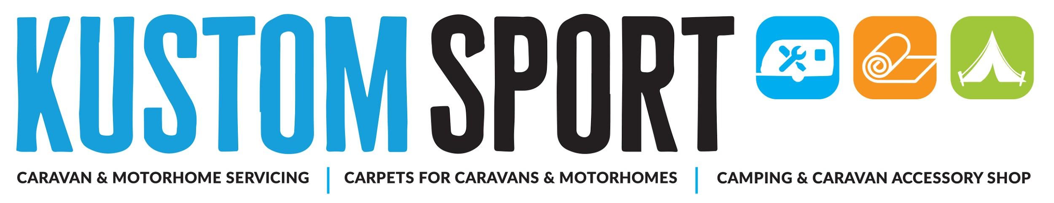

We Offer Everything You Need For Caravanning, Motorhoming & Camping
- Caravan Servicing
- Motorhome Servicing
- Habitation Checks
- Gas Checks
- Damp Tests
- Repairs
- Accessory + Parts Shop with 1,000s of products
- Custom-cut Carpets for All Makes and Models of Caravans, Motorhomes & Campervans

Member of the Approved Workshop Scheme
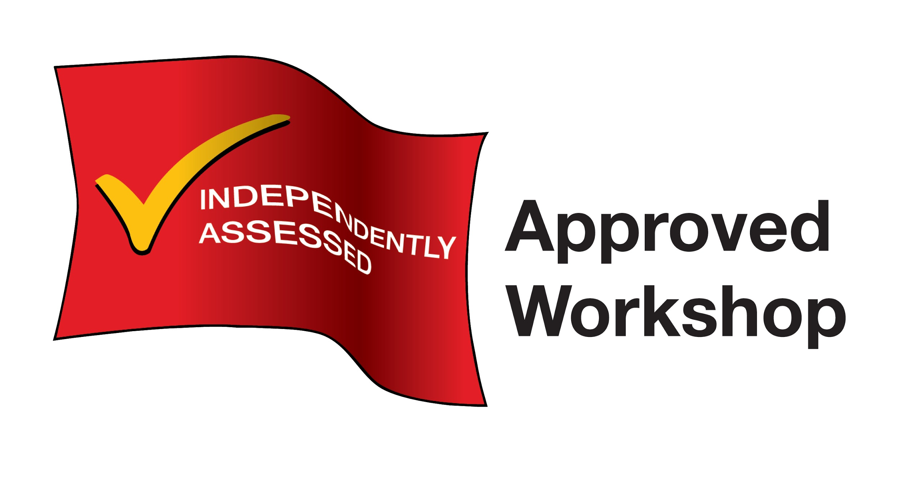
Our purpose-built factory is only 10 minutes from junctions 37 or 36 of M1
Search Google Maps for ‘Kustom Sport Limited’
For Directions
Plenty of Free Parking!

Call: 01226 203 347
Email: info@kustomsport.co.uk
Visit: www.kustomsport.co.uk

