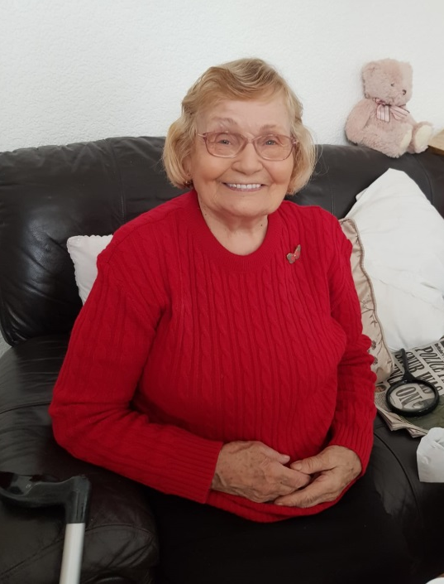

I would like to say how helpful this firm is and it helps people like me. If I ever run out of my medication they are so helpful with getting it sorted for me.

By using Healthcare & You Pharmacy I don’t need to stress about my medication, they deliver it straight to me. I could not ask for anything more.

