

...BRINGING YOU A HEALTHIER LIFE

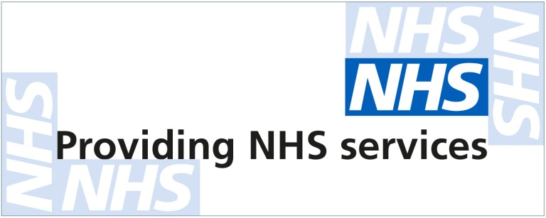
IMPORTANT NEWS
WE ARE NOW OFFERING
A FULL REPEAT PRESCRIPTION
MANAGEMENT SERVICE
IN YOUR LOCAL AREA

Doctors surgeries close to you that we work with
The Vernon Street Medical Centre
Friargate Surgery
Macklin Street Surgery
WILSON STREET SURGERY
Charnwood Surgery
Wellside Medical Centre
Derwent Medical Centre
Brook Medical Centre
Derby Family medical centre
Charnwood Surgery
The Osmaston Surgery and many more…

BUSY WORKING 9-5? IS IT TOO HOT OR TOO COLD
TO LEAVE THE HOUSE?
Here at Healthcare & You Pharmacy we work closely
With your local GP surgery which allows us to collect prescriptions and deliver them DIRECTLY to our patients ANYWHERE in the UK!

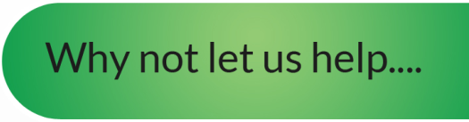
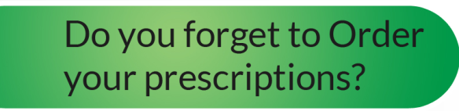
with our FREE services

- Let us manage your medication
- We promise to deliver outstanding customer service
- Provide medications in blister trays or any suitable packaging of your choice
- Free delivery service to your door step or a place of your choice
- We put you first, let us take care of you!

Worry no more! Here at Healthcare & You Pharmacy, we
can automatically order your medication on your behalf with your local GP surgery. We can even set you up to our FREE reminder service. You will receive a phone call, text message or an email to alert you when your medications could be running low so that they can be reordered for you!

Would highly recommend, the service is 100% monthly supply of pills and medicines always on time. Polite and friendly, and found very helpful nothing is too much for them

CUSTOMOER REVIEW

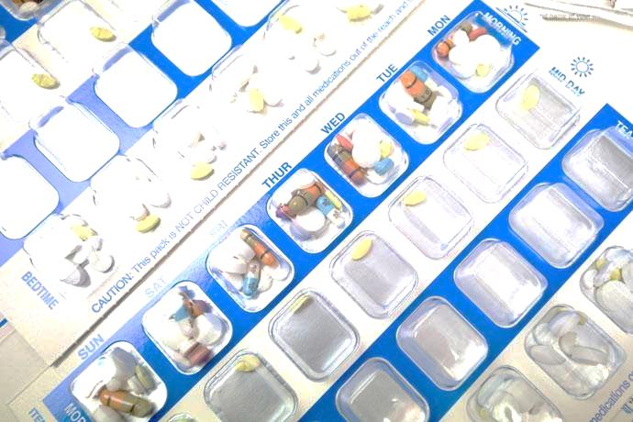
KEEP HEALTHY; STAY COMPLIANT WITH YOUR MEDICATION!
GET YOUR MEDICATION IN WEEKLY BLISTER TRAYS. COMPLETELY FREE OF CHARGE!

REGISTER TODAY AND LET US DO THE REST



Call

us

01332 869229

Visit us at

www.healthcareandyoupharmacy.co.uk

Fill in and Return your
Registration Form FREEPOST

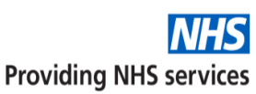

...BRINGING YOU A HEALTHIER LIFE
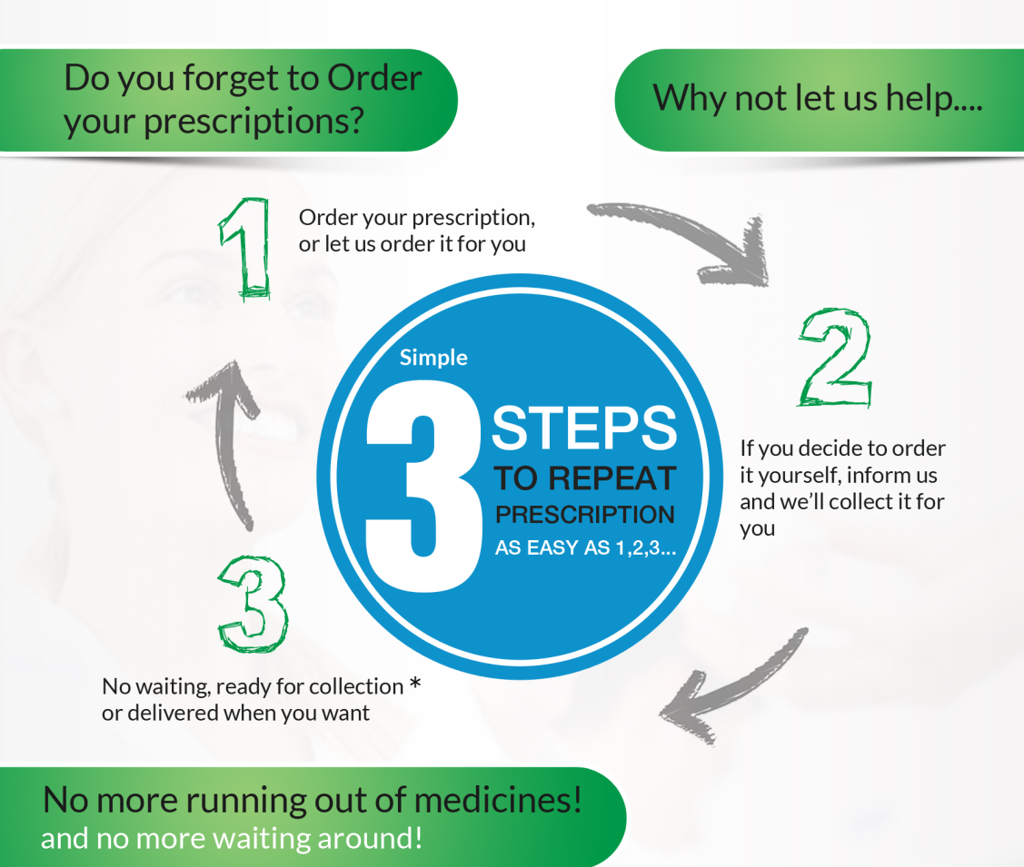
Register to us and tell our team how you would like us to handle your prescriptions.
With the NHS electronic prescription service, we work with your GP surgery to get your medication delivered straight to your door! FREE OF CHARGE! Weather we order for you or if you decide to order yourself.
No waiting! No hassle! Let us order on your behalf or remind you when your next prescription is due so that you never run out!

Healthcare & You Pharmacy is a team made up of qualified Healthcare assistants, Dispensers and Pharmacists working with the NHS handling repeat prescriptions nationwide. We make sure that your medication is ordered from your local GP surgery on time, assembled, checked and then delivered correct for you EVERYTIME! We can contact you to arrange a delivery time and destination that suits you! We can deliver to your home, work, trusted friend/relatives house or any other address of your choosing - completely FREE of charge.
Yours Sincerely
[SIGNATURE]
Chirag Desai
Superintendent Pharmacist

Would highly recommend, the service is 100% monthly supply of pills and medicines always on time. Polite and friendly, and found very helpful nothing is too much for then

CUSTOMOER REVIEW
Would highly recommend, the service is 100% monthly supply of pills and medicines always on time. Polite and friendly, and found very helpful nothing is too much for then

CUSTOMOER REVIEW
MEDICATION ADVICE
SIDE EFFECTS
GENERAL QUERIES
OUR QUALIFIED AND TRUSTED TEAM OF PHARMACISTS ARE ALWAYS ON HAND TO PROVIDE FREE ADVICE
01332 869229

REGISTER TODAY AND LET US DO THE REST

Call

us

on

01332 869229

Visit us at

www.healthcareandyoupharmacy.co.uk

Fill in and Return your
Registration Form FREEPOST

