
Registration Form

...BRINGING YOU A HEALTHIER LIFE
Let us bring you a healthier life…Register today for FREE
At Healthcare & you we put you first, register today.
Simply fill in the registration form below and return it freepost in the pre-paid envelope provided and one of our team will call you within 5 working days to give you an opportunity to ask any questions you may have.
If you need help filling out this form or have any further questions, call us now on 01332 869229, alternatively visit www.healthcareandyoupharmacy.co.uk
(Please tick one of the following)
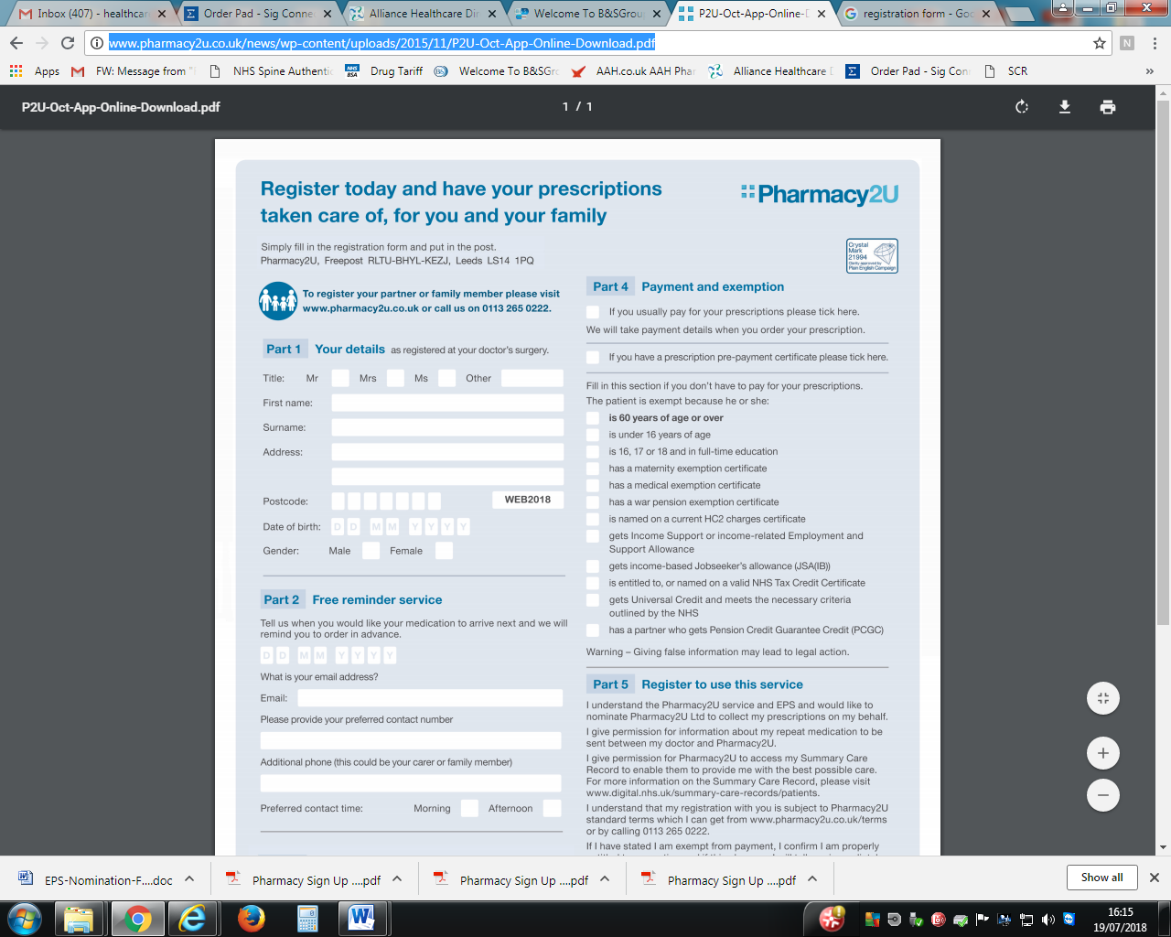
I AM THE PATIENT I AM THE PATIENT’S REPRESENTATIVE

Important: please note that giving false information regarding prescription exemption may lead to legal action. Evidence of NHS charge exemption will be requested up on delivery.

I am the patient named above/carer of the patient named above.
Electronic Prescription service has been explained to me and I am aware that Healthcare & You pharmacy can provide me with a leaflet that explains the service in more detail should I wish too.
I would like to nominate Healthcare & You Pharmacy as my nominated pharmacy for dispensing prescriptions issued by the NHS Electronic Prescription Service; I also give consent for this pharmacy to order my medication on my behalf and share information with my GP surgery.
In order for Healthcare & You Pharmacy to provide the best possible care, they may need to access my Summary Care Records. I understand this and therefore give permission for them to do so. (More information on Summary Care records can be found at www.digital.nhs.uk/summary-care-records/patients.
I am aware that the information provided on this form is strictly confidential with Healthcare & You Pharmacy and I will inform them on 01332 869229 if any of my details regarding my prescription exemption charge were to change.

