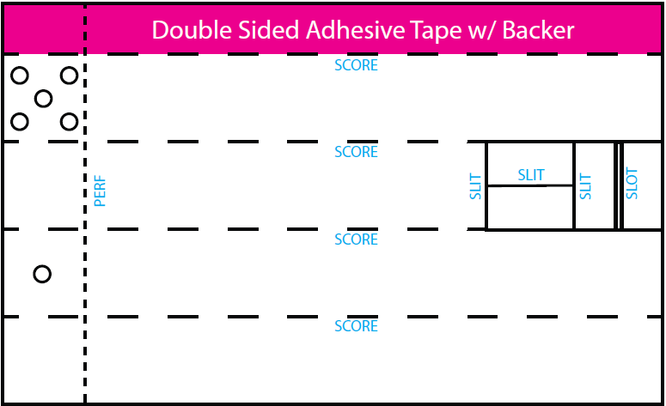

Assembly Video at: www.toke.video
Tear & Toke

Reusable / Disposable Pipes

$2.99
3 Pipes

