Logo
Name: alma e´flora

Descripción de la tarea:
I want a logo: simple and functional. I like fluid strokes, harmonious, and the simplicity in shape and colour, maximum 3 colours. I need to stamp the logo in a handmade soap with a seal, or print on the label in a little bottle of essential oils, so I want that the logo is visible when the size is reduced. Also I want that it is legible when is in black and white.
It can be a symbol and the name or only the name.
I prefer the text in lowercase letters (alma e’ flora). Whatever you doing with the apostrophe (’) depends on your imagination.
I’m open to your creativity!!
Keywords: nature, medicine, health, love, flora, God, indigenous rows, organic, terra.

What is alma e’ flora?
Alma e’ flora is an entrepreneurship that offers physical, emotional and spiritual healing tools through use of essential oils that are extracted from several aromatic plants including amazon plants. This plants are been sowed, cultived and harvest by our self in an organic way respecting the moon cycles and our mother earth or harvest by indigenous.
The essential oils are the hearth of the therapies that we provide.
From de essential oils we make organic products for the skin care, we do aroma therapeutic massages, we offer personalized consultations about health nutrition and emotional diseases, recognizing that the power of the healing come from the self-love.

Who is behind alma e´flora?
Nowadays, Alma e’ flora is a persistent idea that don´t leave me sleep, that make my cells vibrate all the time. I love plants, I love essential oils, I love dance and I love my family. I’m a women with 35. I’m wife and mother of two boys. I’m doing my first steps to begin my entrepreneurship, my business. This logo is one of them.
Which are my clients?
My target market is people who want take care their self being respecting with the nature, who doesn´t like chemicals. People who want deep in the best way for nourishing physical and emotionally.

Thousand thanks!
Paola Jiménez
Bogotá, Colombia, South América.

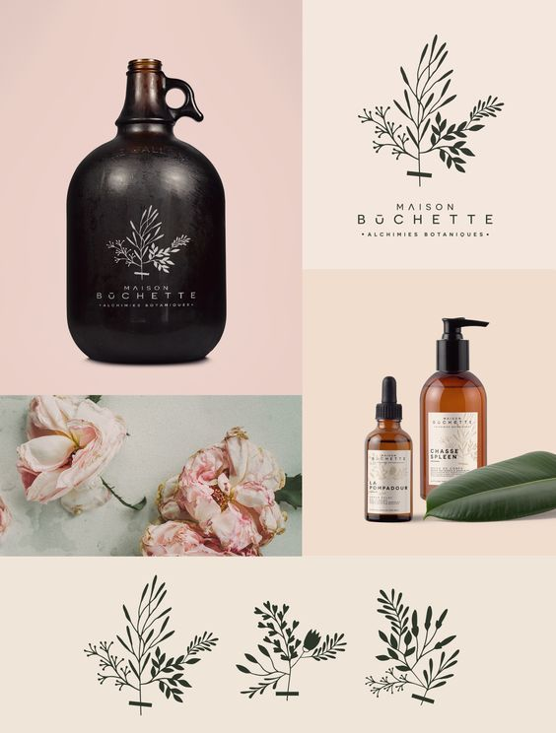
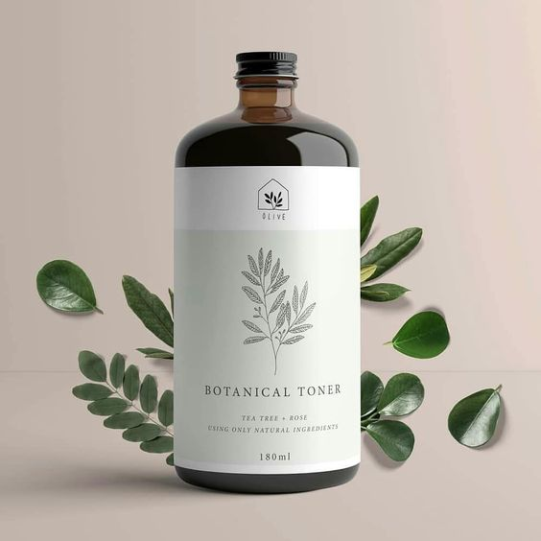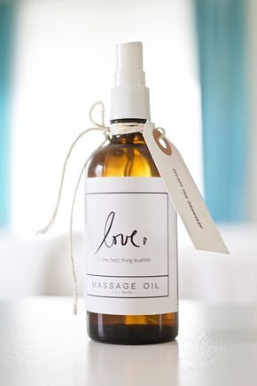
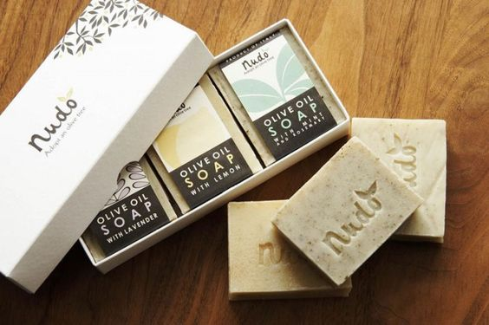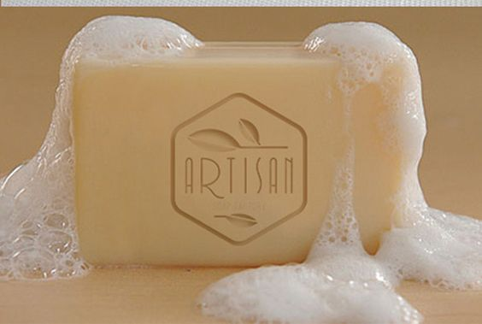
I would like to print the logo in a wax. These are examples but maybe I’m not too classic.
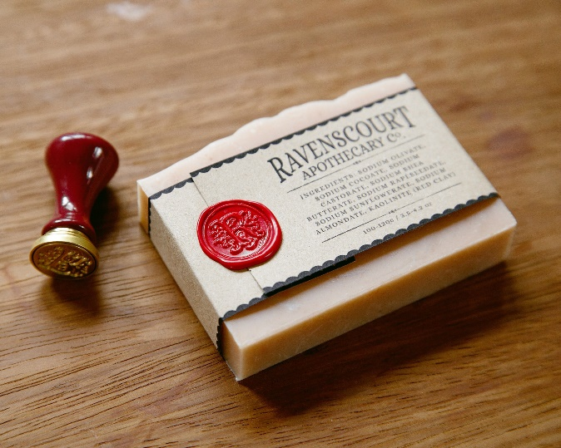

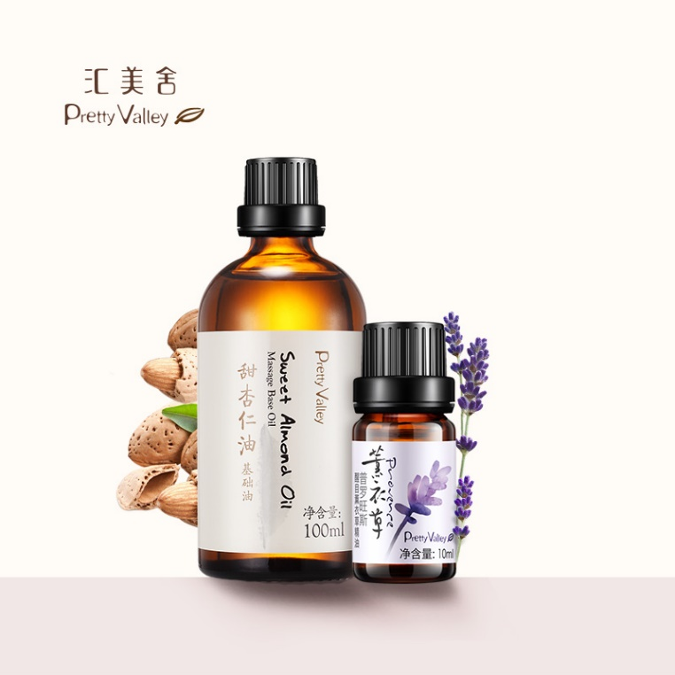Different sizes
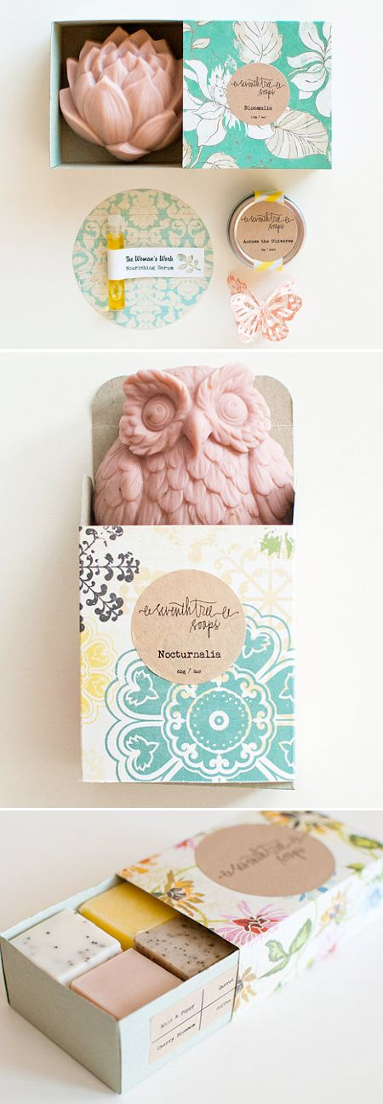

Colors that I like:
https://www.design-seeds.com/category/in-nature/flora/
