Business



AAA Painting & Decorating
0444 688 544

24 Jobs

By service
20 Painting
12 Plastering
8 Rendering
See all

By Location
16 Eastern Suburbs
8 Inner West
See all

AAA Jobs
Painting and plastering job
Completed: 7 July 2018
Bondi Junction, 2022, Eastern Suburbs
Job size: medium
Description: plastered and painted interior of three bedroom house

4 photos
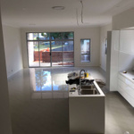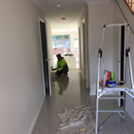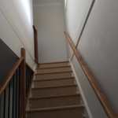
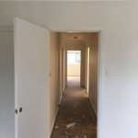

Painting job
Completed: 15 July 2018\
Rose Bay, 2024, Eastern Suburbs
Job size: small
Description: painted two rooms and stairwell in luxury five bedroom house

3 Photos
