Summary
Intelliglobe is a new UK company developing an incredible range of high definition digital globe style displays for use in education, gaming, advertising and high-end lighting.
The i-globe range of LED based displays will offer consumer oriented products retailing from prices less than £300 including tax, controlled by your smart phone and with web access to masses of content, including the ability to render your own content for display on the globes
As an educational tool, the i-globe could display Planet Earth with a variety of overlays – e.g. weather, bird migration, pollution, tidal patterns, live flights and other planets. It can also render in 3D to show geographical features or weather patterns. The display can also be used as a lighting system, with the ability to dim the light for use as a night light for younger children or to display disco lighting affects based on the type and volume of music being played. The i-globe will also be a novel and captivating display for advertising – in hotel lobbies, airport executive lounges, shops and trade shows.
The technical team are world leading inventors of high end LED based advertising displays and invented a LED based globular display over 15 years ago.
The spinning arms on the lowest end model will create an amazing image of ¾ million pixels with just 768 LED’s.
We are now using the latest technology to create a low cost, high definition product range with the key drivers being
- A Beautiful Design
- An Amazing Display

Product Range
A range of different products will be released, starting with the i-globe 300c, a 300cm diameter display for consumer/residential use.

A more rugged display with even higher resolution, that can be operational 24 hours a day, and in bright conditions will follow, including a 500 cm display.
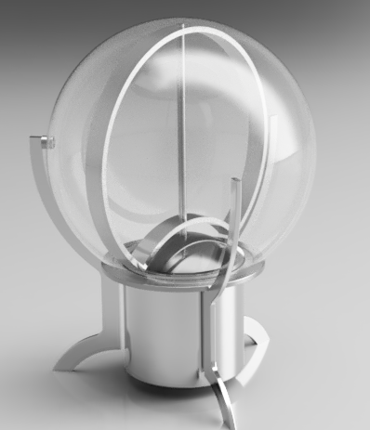


Potential partners in Europe have indicated that such a low cost product could be subsidized or even donated to schools with a “sponsored by” message appearing at boot up.

Previous Designs
The founders of Intelliglobe have pioneered the development of LED light displays – mainly for large scale advertising purposes, but also for commercial sue – e.g. a LED home lighting range for John Lewis stores.

The BusLED display currently operating on London buses since October 2017.

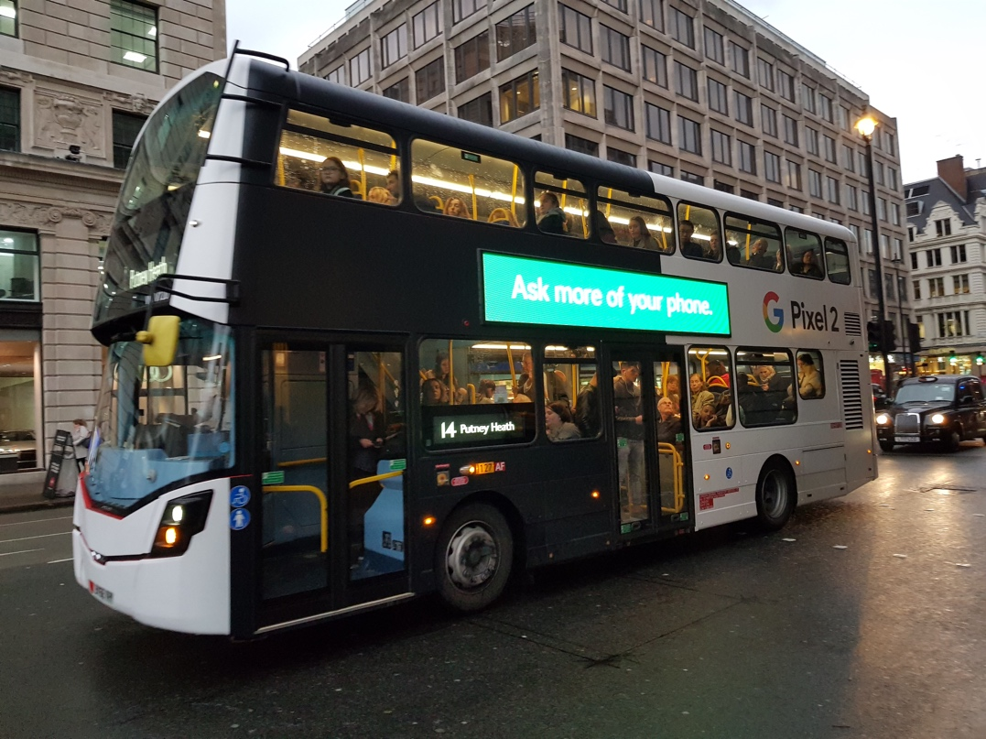

A more complete view of the projects undertaken by the technical team can be found on the following web site www.sirmon.co.uk/#works. In particular, navigate to the Litelogic image (a screen shot from the Avatar movie) to see moving displays.

