CLEANIT REVIVAL LOGO 2018

- A brief overview of your company

We are CLEANIT a telecommunications installation company based in Cameroon
- Which industry your business is in
Telecommunication
- What text you want to include on the logo
None
- Examples of any existing logo/materials

- Company colour schemes (if applicable)
Vodacom red: https://www.vodafone.co.uk/
Nera red : http://www.nera.net/network-security.html
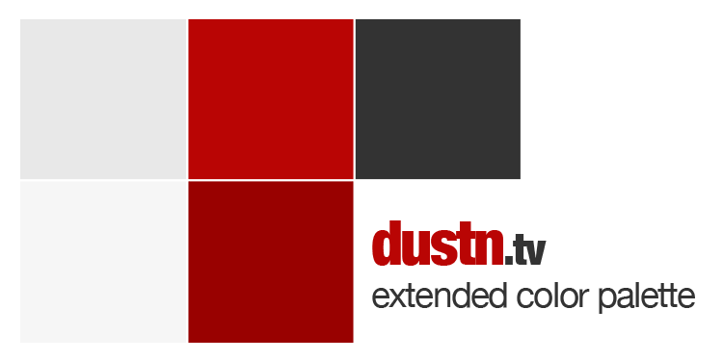

- If possible examples of any logo's you particularly aspire to

