-  We aim to empower our customers to position themselves as Leaders in their space  - Leaders in Quality  - Leaders in profitability  - Leaders in competitiveness  - How we do Business:  - ProcessChamp takes a truly collaborative approach. We first work together to explore and understand our customers’ problems. From this point, we lean on our deep network of technology providers to design and deliver the best possible solution to the problem.  - The Result:  - Elegantly Integrated Solutions  - el·e·gant: Pleasingly ingenious and simple | ProcessChamp  1409 Allen Dr., Troy, MI |  | - Custom Integration Competencies  - Automated Inspections  - -Inline Vision  - -3D Metrology Integrations  - -Magnetic Particle Inspection  - Adaptive Tooling  - -AGV Stations  - -Body-In-White Tools  - -Sheet metal assembly  - Robot Guidence  - -Flush and Gap optimization  - -Smart, adaptive robotics  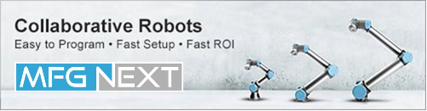

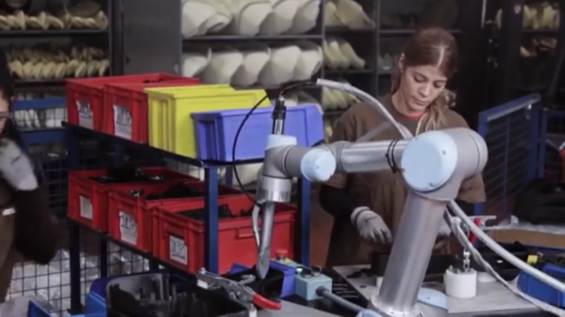  Robotic Integrations  - Assembly  - Pick and place  - Vision guided applications  - Inspections  Machine Vision Integrations  Front of line – Inline – End of line  From 3-D point clouds to 2-D profile and even Magnetic Particle Inspection, our team has a deep background in machine vision and metrology. We’re hardware agnostic, meaning we’ll always bring the best solutions available to your unique challenges. | “Process Champ brought the right people and technologies to the project and has helped us win more business”  -Paul Bore  President  Trenton Forging  View and edit this document in Word on your computer, tablet, or phone. You can edit text; easily insert content and seamlessly save the document to the cloud from Word on your Windows, Mac, Android, or iOS device.  Adaptive, Flexible Tooling  AGV Stations – BIW – Frames – Welding  Sensor Consulting  2-D Vision | Contact Us  ProcessChamp  1409 Allen Dr., Troy, MI  734-417-5799  bLahart@ProcessChamp.com  www.ProcessChamp.com

