
DON’T STRESS
Your DOT Medical Examiner has given you 3 months to check for and correct a potential concern: SLEEP APNEA
DON’T WAIT!
This may require the following steps:
1) Conduct Sleep Apnea Testing
(If negative finished go to step 5. If positive continue to steps 2 through 5)
2) CPAP/BiPAP/ASV Titration
3) Acquire Home PAP Equipment
4) 30 Days on Home PAP Therapy
5) Follow-up DOT Appointment Before 3 ….Month Period Expires.
CALL TODAY
AT HOME SLEEP STUDIES 702-463-8062

DON’T STRESS
Your DOT Medical Examiner has given you 3 months to check for and correct a potential concern: SLEEP APNEA
DON’T WAIT!
This may require the following steps:
1) Conduct Sleep Apnea Testing
(If negative finished go to step 5. If positive continue to steps 2 through 5)
2) CPAP/BiPAP/ASV Titration
3) Acquire Home PAP Equipment
4) 30 Days on Home PAP Therapy
5) Follow-up DOT Appointment Before 3 ….Month Period Expires.
CALL TODAY
AT HOME SLEEP STUDIES 702-463-8062
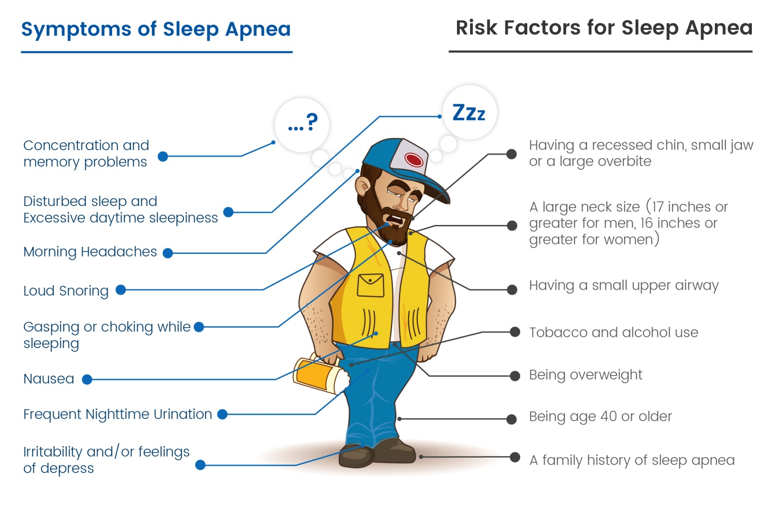Commercial Drivers Can Manage Sleep Apnea & Maintain Their CDL
CALL TODAY

At Home Sleep Studies

702-463-8062

Commercial Drivers Can Manage Sleep Apnea & Maintain Their CDL
CALL TODAY

At Home Sleep Studies

702-463-8062

