 What we want from our design:

Clear calls to action.
Clean, uncluttered design.
Space for 1500 words of content under various headings.
Incorporation of our brand colours with suggestions for new colours that complement them
Incorporation of logo into menu matched to page.

Some background:

We are rebranding our existing site around our new logo and want to move away from using blue heavily.

Our current site can be found here https://usave.co.uk/broadband/best-broadband-deals/

We will be using this competition to find someone to work with in future, our site will have around 50 landing pages in total.

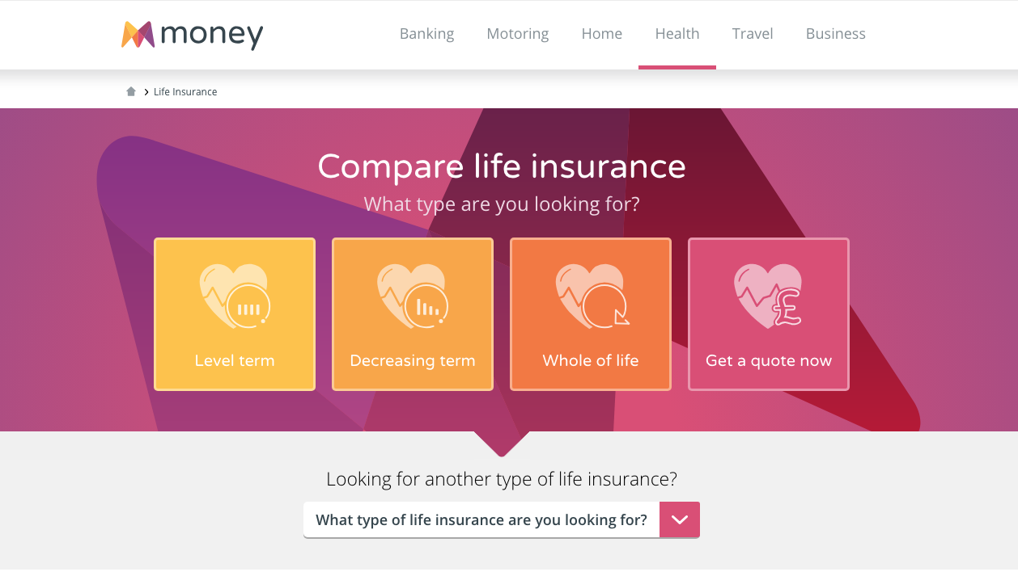

https://www.money.co.uk/life-insurance.htm

What we like about this page:
The header gives a clear call to action and shows the product variants clearly.
We also like the simple and clear menu.
Very clean design.

https://www.moneysupermarket.com/life-insurance/

What we like about this page:
Ample space for content.
Nice explainer graphics.
Clear concise design.

https://www.confused.com/life-insurance

What we like about this page:
Clear calls to action
Nice use of brand colours, especially at the bottom.

.

