Top side:
- The logo and bulb are too close and in centre. Please position them as below:

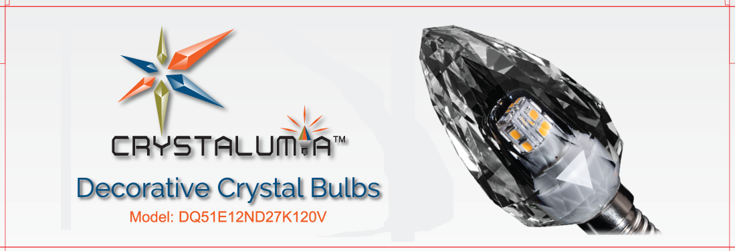

Back side:
- In the second footnote, please change copy paste bellow:

LED lifetime in 25°C operating environment. The expected average lifetime in residential use is 15,000 hours (13.7 years based on 3hrs/day).

