Top side:
- Please move the bulb and logo to the left (too much weight on the right side) – see Top_repositioned.png

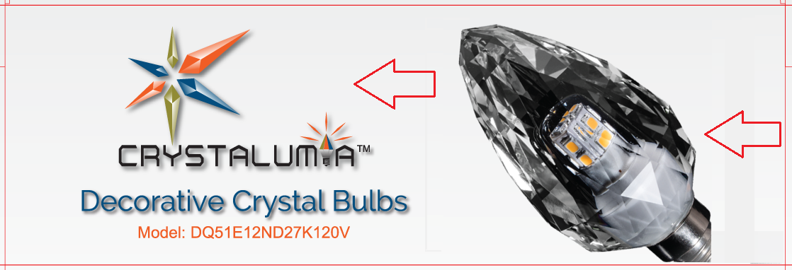

Back side:
- Please make the colour temp and lighting fact labels and their contents bigger as much as possible
- Please increase the font size as much as possible (texts are not easily readable in the actual size especially the footnotes)
- In the second footnote, please change “(13.7 years) Based on 3hrs/day.” To “(13.7 years based on 3hrs/day).”
- Please remove the word “this” from “this packaging” (above no rain symbol)
- Please narrow the white margins (4 sides) around the barcode to half and re-align the texts and images located at the right accordingly.
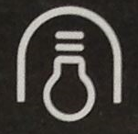
- Please try to replicate below symbol for “Use in open luminaire only”, the closer to this the better.

