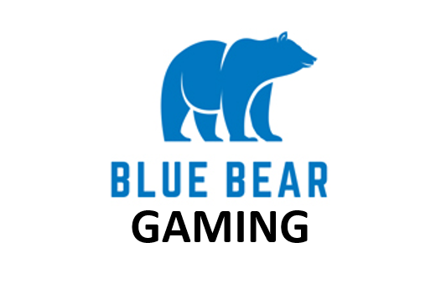
Would be fun to do light animation of bear turning with shades on and then back to this solid stance

ABOUT US
We are a proven team of designers and gaming developers with decades of experience in egaming
regulated markets. We are located across the globe with staff in Canada, Malta, Costa Rica and the UK.

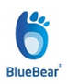
WHAT WE DO
We build online and mobile enabled casino games for the B2B egaming marketplace in Europe.

CORE DEMOGRAPHIC - Woman (75%) Ages 30+ years of age / Men (25%) Ages 45+ years of age

BRANDING
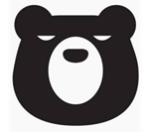
Our company will be represented with ‘hip’ bears. Cute, casual and always ready to party. They dance, dine and are merry characters who enjoy wearing shades with a drink in one hand and the other in a honey pot. We will have animated bears on our corporate site as well as on our game loading screens to establish our unique sense of fun and play with players.
https://www.youtube.com/watch?v=a4fv-BtzNmY (this sound track would be something that we use to demo or games and establish our ‘chill’ bears with the B2B marketplace at tradeshows etc)

COMPETITORS www.elk-studios.com
www.magnetgaming.com
www.irondogstudios.com

