Title:
Redesign key parts of organic food ecommerce website

Job Type:

Website Design - Mobile responsive ( we need perfect design for mobile ) ( PSD layout only )

Background:
Happy Trade is an enterprise focusing on conneting produces from local farmers to users. Shoppers can buy direct produces from their farmers on our website. Every farm also has its own page and story on our website.

We set up in 2017, using a modified template plus redesigning part of it to customize to our theme. Our current website: https://happytrade.org/

Our challenges:
Our current design gets good feedback in terms of look and feel. General feedback is: fresh, nature and modern. But when coming to shopping experience, there are some issues with UX/UI that needs to adress:
- Website navigation: the ecommerce part is not visible and easy to navigate/buy from homepage and even within shop page.
- Navigation to buy among pages is difficult to proceed mutiple orders.

Target Audiences
- Age: 25-45
- Gender: Female
- Interest: Healthy & Fresh food.
- Characters: Educated urban female living in cities, interested in looking for green and healthy food for their family. Mostly married with kids.
- Location: 100% in Vietnam
- Language: 100% Vietnamese

Brand
- Mood and tone: Green, fresh and natural.
- Brand colour: Green, grey and white
- Current colour:
+ Add to cart button, hover button, hyperlink: #69BD43
+ Background color: #fff

Goals:
- Improve ecommerce site navigation
- Inscrease Conversion Rate
- Responsive design for mobile
- Make website look ‘fresh’

Number of pages required:
4 pages:
+ Homepage: https://happytrade.org/
+ Shop page: https://happytrade.org/cua-hang-thuc-pham-huu-co
+ Product list page: https://happytrade.org/rau-cu-qua-huu-co
+ Product detail page: https://happytrade.org/toi-ly-son

Task Details

Our site is in Vietnamese. To help you understand the website’s workflow, we translated our current designs into English below. ( please download image files for zooming. )
Feel free to receive your comments/suggestions about layout, color, font.

1. Homepage

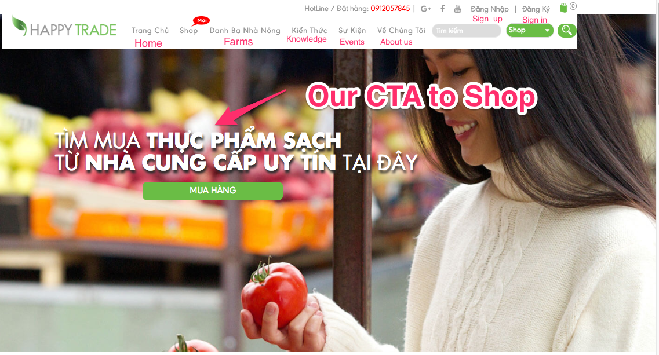

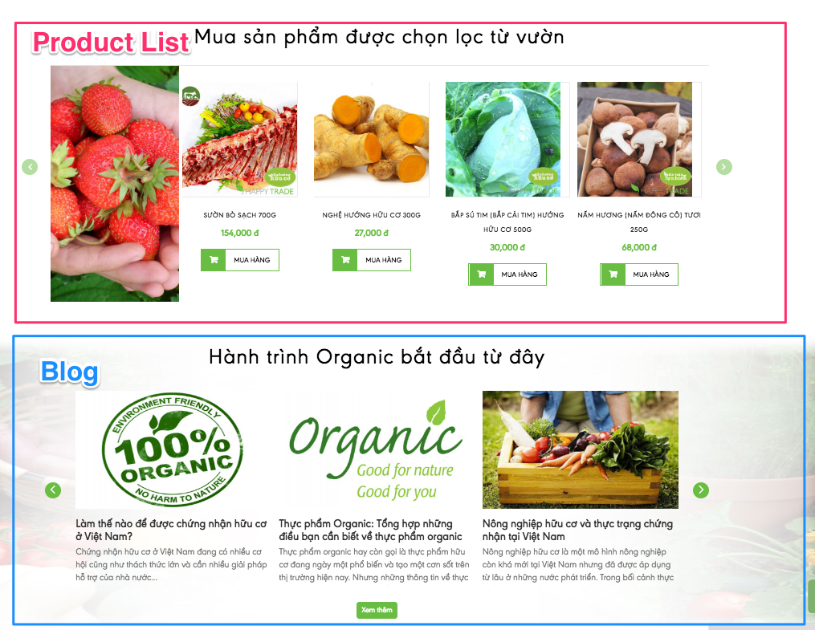

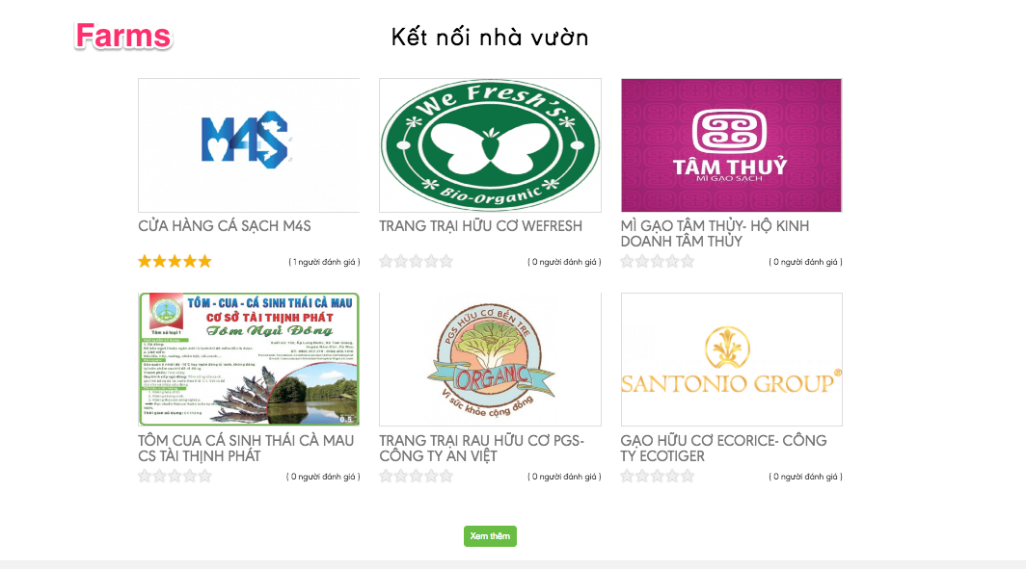

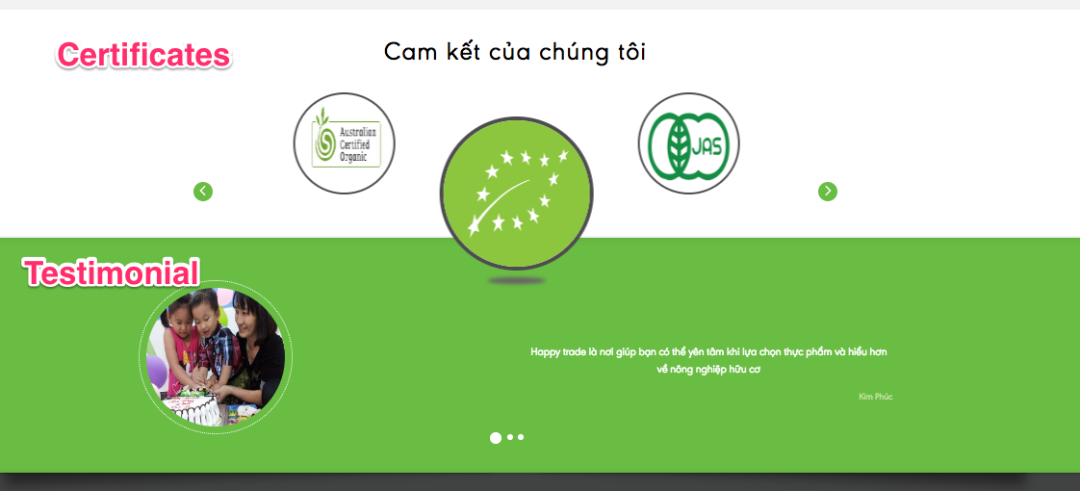

Our objective:
- We want users can buy product or at least navigate to shop with ease
- Show farm list because it’s our advantage.

2. Shop

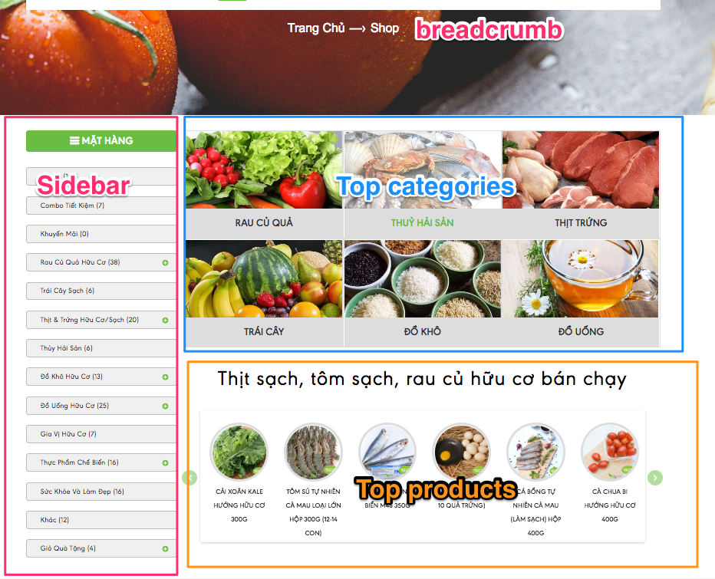

Our objectives:
- Show more categories
- Re-design sidebar.
- Show more products in grid format to lengthen the page.

3. Product List

Product list is showed when you click on a category, e.g: https://happytrade.org/rau-cu-qua-huu-co
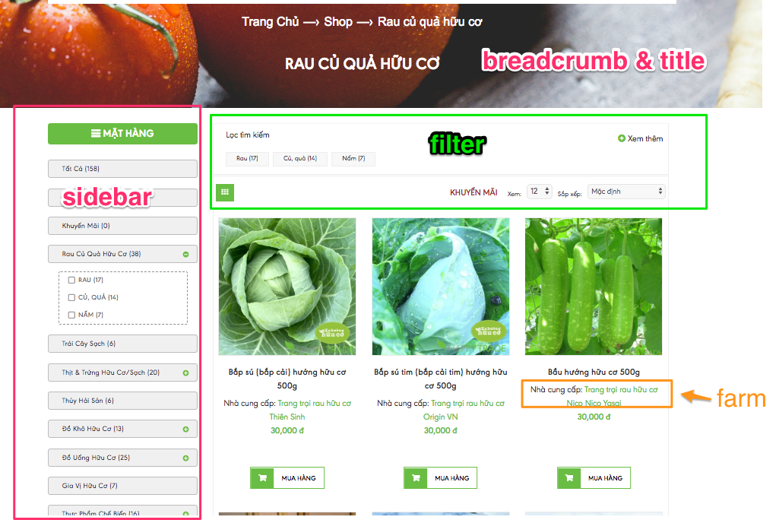

Our objectives:
- Reduce spacing between 2 rows of products.
- One product must have a linked farm.
- Outstanding ‘Buy’ button and pricing text.

Product Detail

e.g:
https://happytrade.org/sup-lo-xanh-huu-co

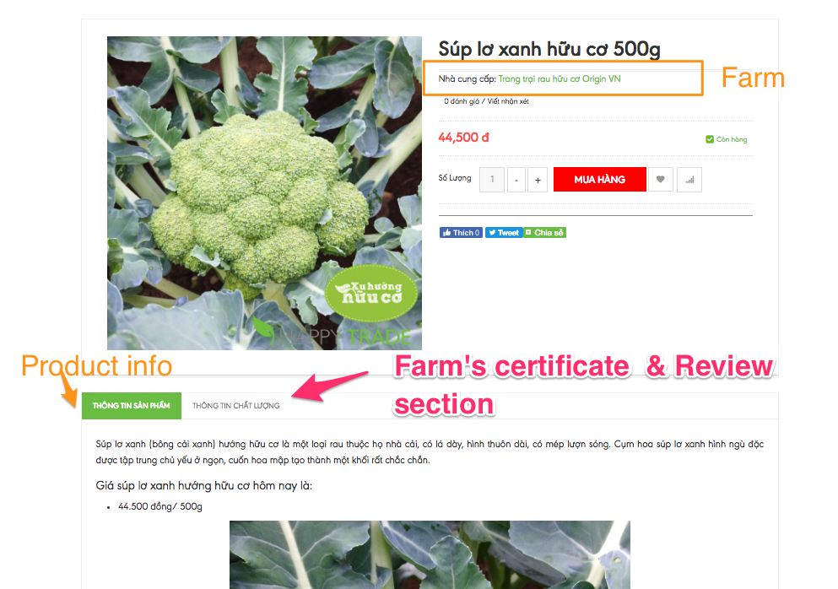

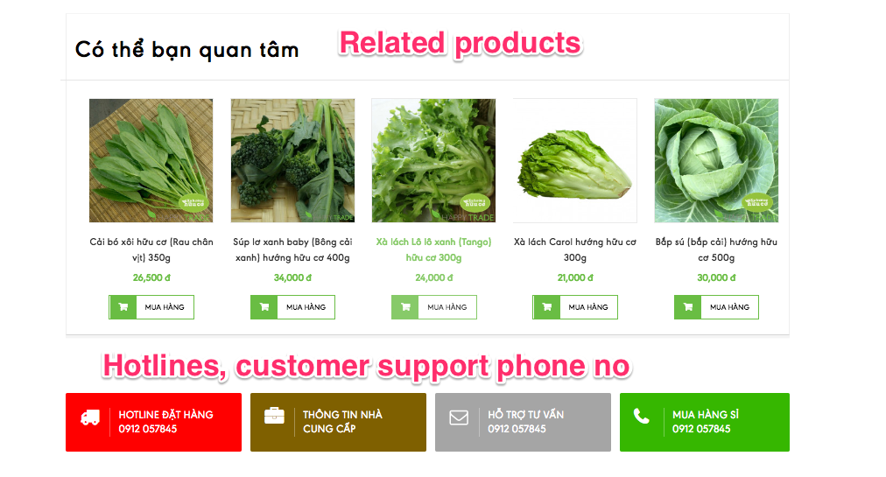

Our objectives
- User can easily see product’s information and farm’s certificate.
- Make farm’s certificate section outstanding
- Move related product sections to the top ( below the the ‘Buy’ button )

Deadline
- First proposal: 31/07/2018
- Feedback: 03/08/2018
- Final proposal: 10/08/2018

Files

