MACY’S THANKSGIVING DAY PARADE AMERICAN BRUNCH
WITH OUTDOOR VIEWING AREA

November 22, 2018
8:00 AM – 12:00 PM

“THE BEST THANKSGIVING EXPERIENCE IN NEW YORK CITY”

Get exclusive access to the biggest Parade in the world. The iconic Macy's Thanksgiving Day Parade has been putting smiles on the faces of the young and young at heart for 92 years now, and for many, it just isn't Thanksgiving without it.
Enjoy the incredible views of New York City’s 2018 Macy’s Thanksgiving Day Parade with your family and friends! From the extravagant floats to the humongous balloons to the intricate performances and beyond, the parade has something for everyone.

- Incredible views of the 2018 Macy’s Thanksgiving Day Parade
- Access to Outside Viewing Area right on 6th avenue sidewalk
- Gourmet Full American Brunch served to your table
- Specialty brunch cocktails
- Guest Entertainment: Magicians, Balloon Artists and Face Painters
- Professional Photographer and Your VIP Pass Coordinators on-site
- NYPD approved Credentials For Access

WHAT YOU CAN EXPECT

While millions tune into watch the Macy’s Thanksgiving Day Parade on television, you can enjoy an up close and personal view just steps away from the action. Our parade experience offers a fun mix of inside and outside elements. Inside, guests will enjoy an unlimited, full American brunch complete with specialty cocktails as they experience the world-famous parade.
Outside, guests can step out to enjoy the action just steps from our exclusive sidewalk area.

OUR PROMISE

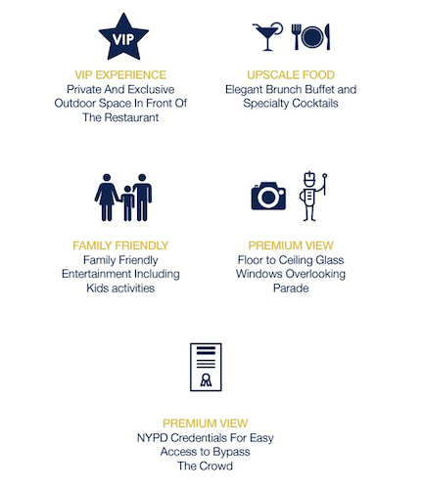

- VIP Experience – Remove word Private. Please leave: Exclusive Outdoor Viewing Area in front of the restaurant
- Upscale Food – Elegant Full American Brunch with Specialty Cocktails
- Family Friendly – Family Friendly Entertainment Including Kids Activities
- Premium View – Remove: Floor to Ceiling Glass Windows Overlooking Parade
- Premium View – NYPD Credentials For Easy Access to Bypass the Crowds

MENU

Full American Brunch from our 2017 event.
This year’s menu will be just as wonderful and will be served to the tables.

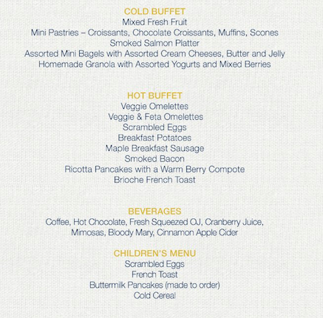

WHAT PEOPLE SAY ABOUT OUR LAST THANSKGVING BRUNCH
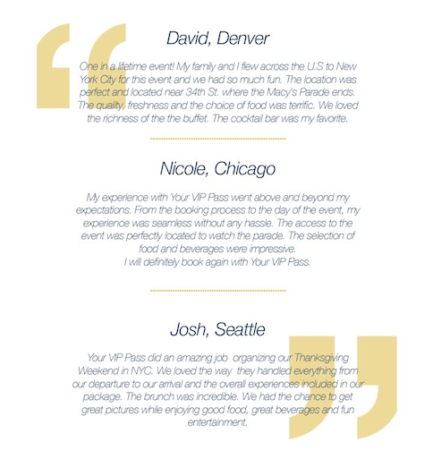

(SELECTION OF IMAGES)

LOCATION

(MAP)
Your VIP Pass Logo

