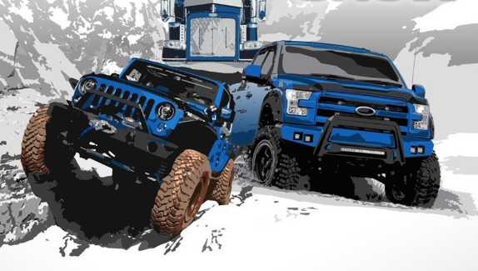
We like the idea of this being on the business card, but instead of a Jeep and large truck we are looking for other options like a GMC Denali, Dodge Ram, Ford Raptor, Chevy Silverado.

