My company is a lighting company so I am going to put theses logos on my lighting gear, there is a lot of different part of gear from a lot of different size and shapes so I will need different stickers size…
As you know, I am French and I really like a French Actor, Jean Pierre Marielle, he plays in a film that inspired me for le logo.
The name of the company is OSEKU Lighting.
OSEKU is the phonetic way of saying “OH CE CUL” in French which means, “What an ass”, I know it’s original, but it’s a cue that This Actor says often in the film, it is kind of a joke in a sens.
My Logo List is made of 4.
1. Main Logo + Title of Company
2.Laughing Facial Expression
3.Suprised Facial Expression
4. Title of Company
You’ll find all the pictures and sketches in the file “Pictures”
About the Actor:
-Sympathetic, nice, friendly
-Vulgar, Straight Forward, Truth, Loudmouth.
-Emotional Person, Spontaneous, impulsive
-Hedonist, says what he feels and thinks.
-Around 45/50years old.

INSPIRATION
For the expression
Film: “Comme la lune”
http://www.hds.to/films/comme-la-lune-1977-streaming.php
Key moments :
00 ; 00 ;00 to 00 ;02 ;00
00 ;25 ;00 to 00;28;00
01;12;00 to 01;14;30
- Main Logo:

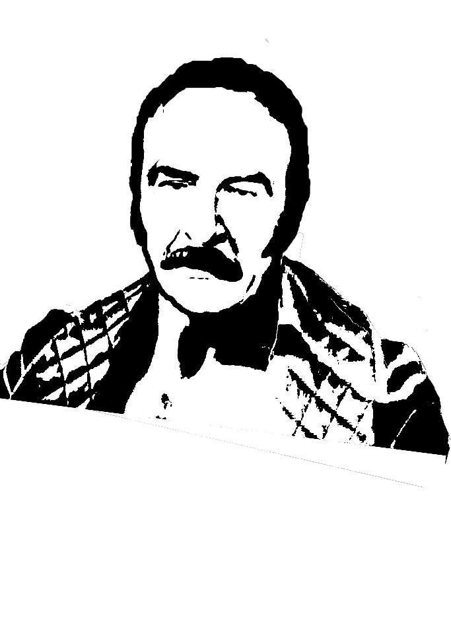
(For all the faces I would like having him in a nigh silky nightdress, like this logo previously made)

(Should looks like he is looking at a girl, from the corner of his eye ( look toward left) He wears a thick Nightdress.

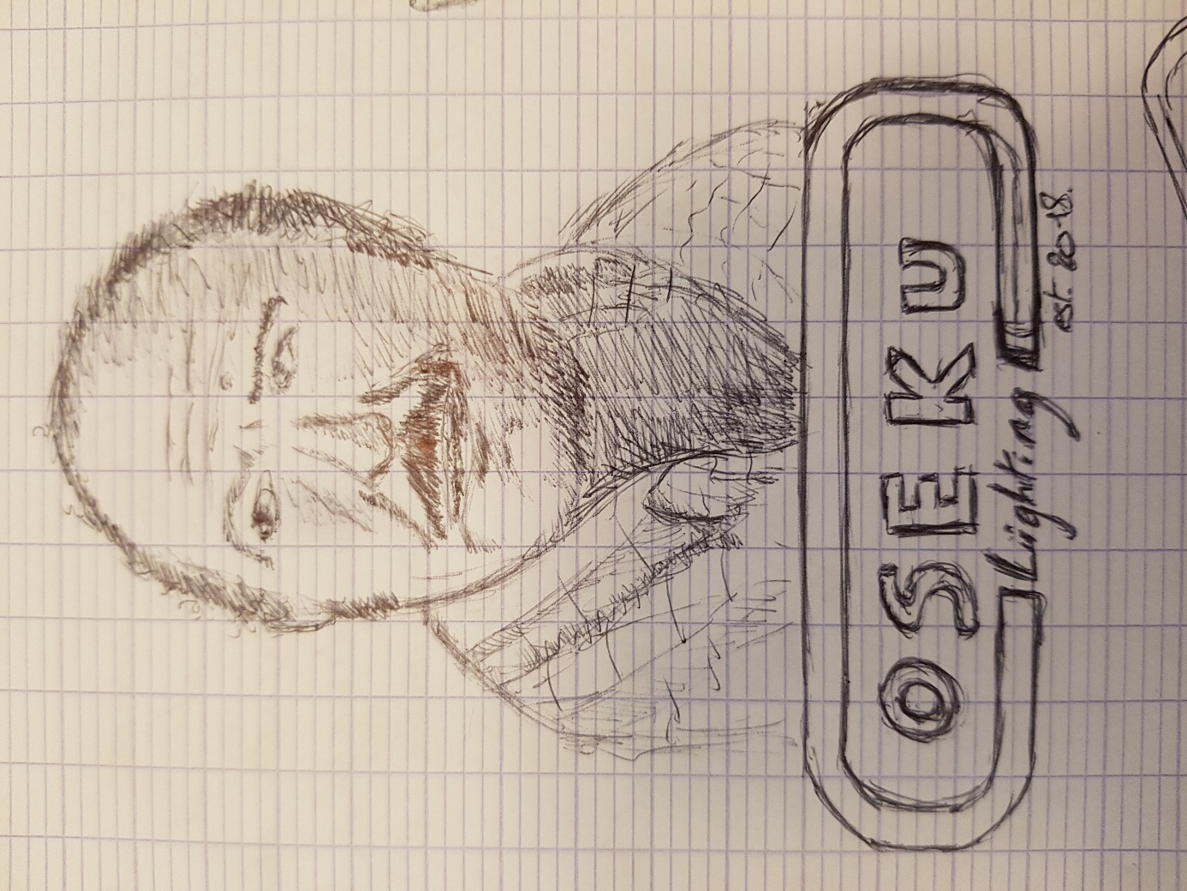

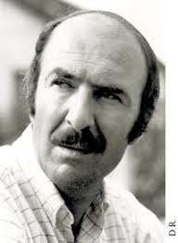

- Second Logo (Laughing Expression) No Title of Company

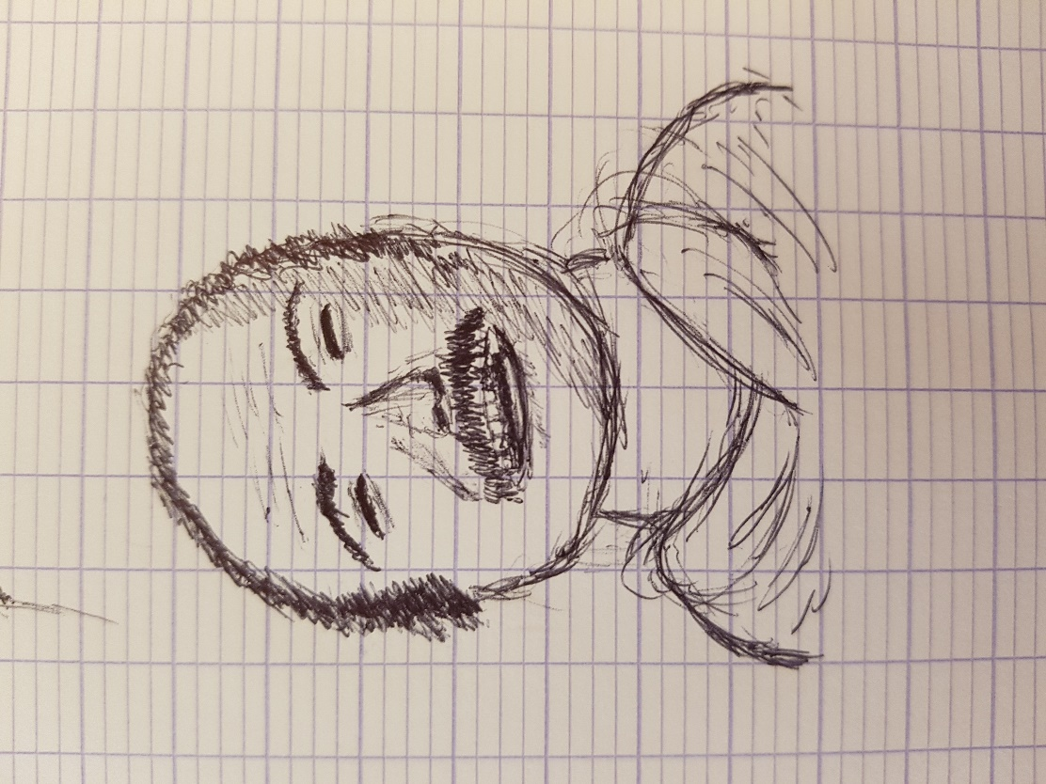
Should Looks like nice, friendly, should be more ¾ toward right, mouth open and eyes closed.

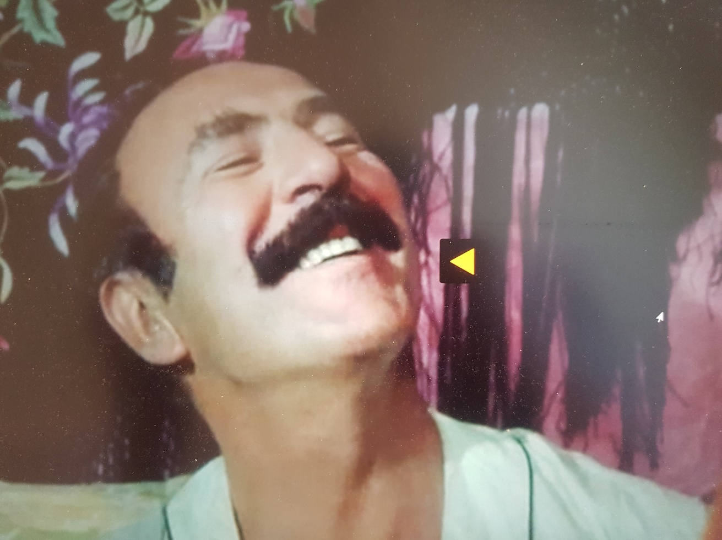

- Thrid Logo Surprised Expression:
Should look like surprised, mouth open as if a girl got naked in front of him ( like in the film) ¾ toward left side but looking straight to camera.

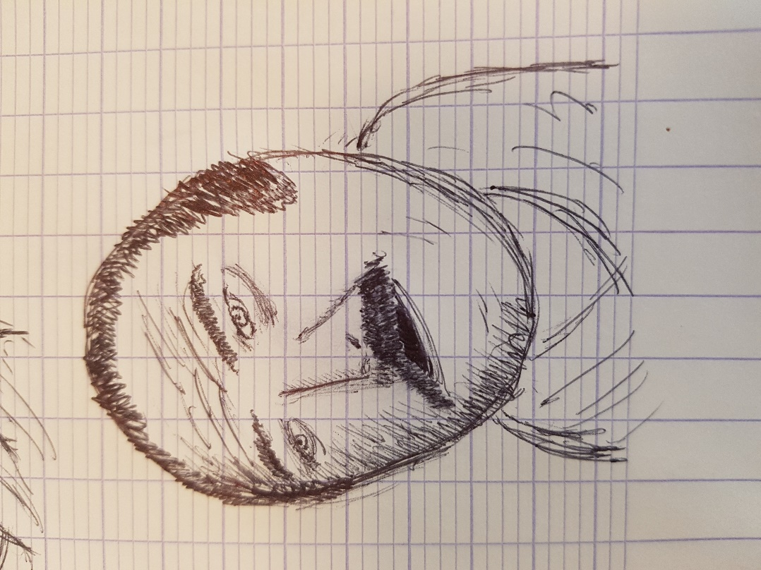

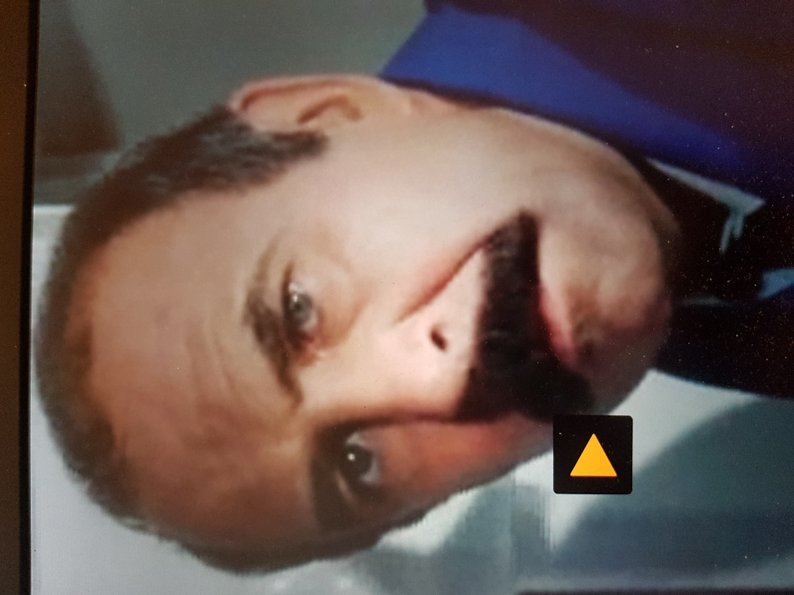

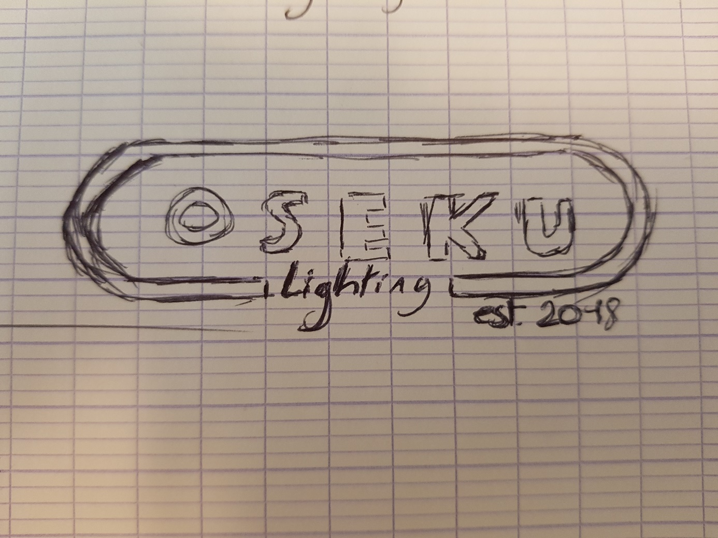
- Title of Company

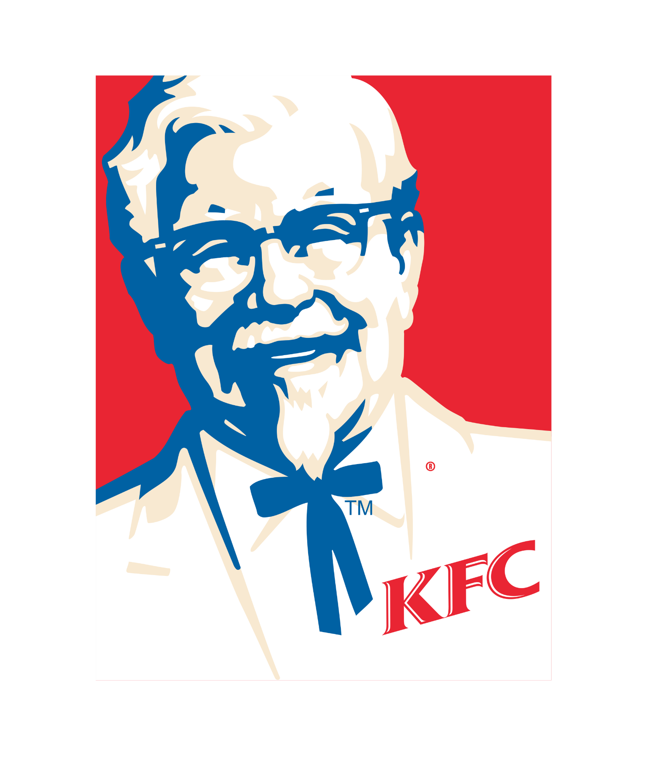
Style Inspiration for Faces:

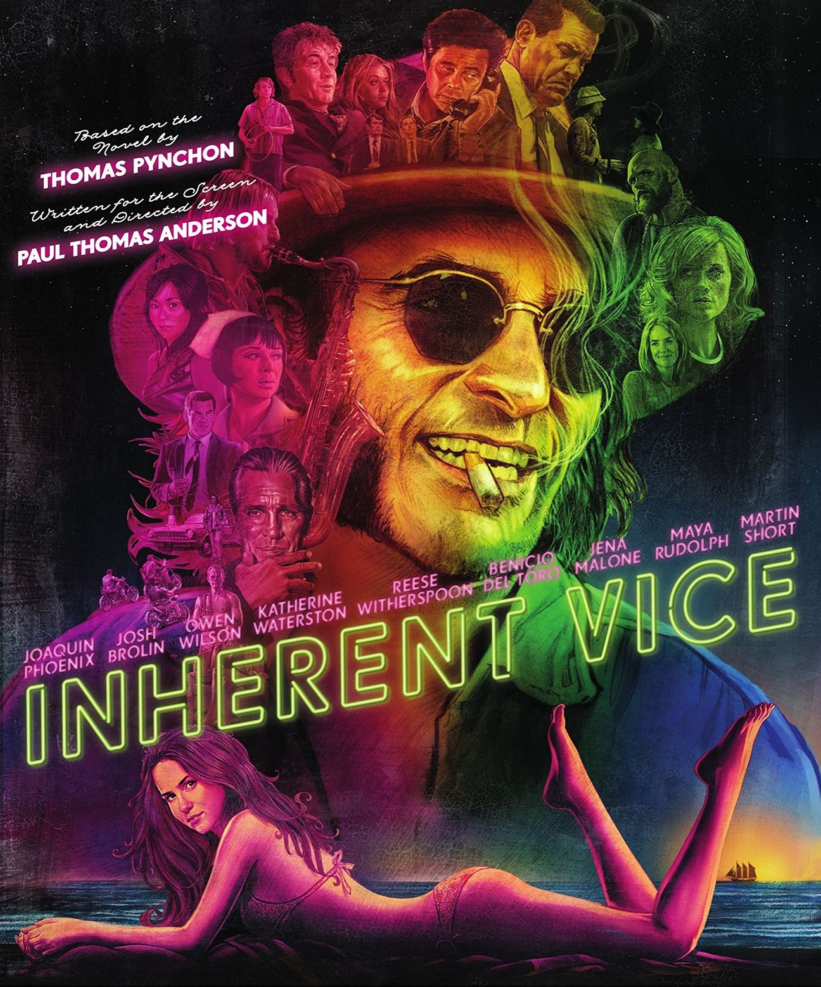
Inspiration for Typo

Colors:
I would like to have everything in white, with clear background or if I can have a sample of everything in this color ( color on the light below). I might like this.

