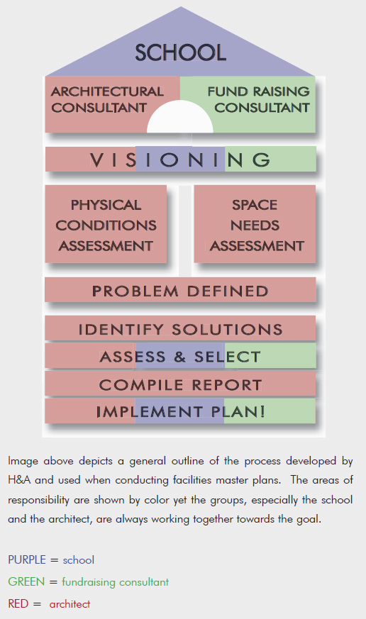
This is the current image. A PDF of it is also in the files. I’d like something that covers the following:
- Easy to understand at a glance (the current image makes the process look daunting)

- Updated colors
Our company’s main color is Pantone 201C (a maroon-ish color), secondary is Pantone Cool Gray 11, text is Black. Since the red is so vivid, I don’t know that it needs to be the foremost color. Any additional colors should complement our brand’s colors though.

- Still conveys that there are 3 parties involved (hence the three colors) in the process but does it in a way that’s not so distracting/messy

- Slightly 3D could be nice or just a little less flat and static-looking – it should “flow” but I’m not saying do a flow chart

- IF and only IF, something architectural-looking could be incorporated WITHOUT affecting the main purpose, then that would be nice

- I want an EPS file so that it can be resized without distortion, whether a PowerPoint or printed for a 4 ft. board

- Portrait or landscape, it’s up to your design

