“The General” By Patriot Hitches, LLC - Specifications
- Ball And Accessory Mounts
- Meets Or Exceeds J684 SAE Testing Standards
- Ideal For Marine, Agricultural, Recreational And Of Course - Military Use
- Adjustable - Matching The Height Of Your Application
- Lifetime Warranty
- Sturdy Steel Construction
- Black Powder Coat Finish Resists Rust And Corrosion
- Simultaneous - Use Accessory Attachment Option
(See “The Specialist” Accessory)
- Max GTW = NEVER Exceed Your Vehicle Limits

By The Numbers….
- Maximum Rise: 11” / Minimum Rise 3”
- Maximum Drop: 11” / Minimum Drop 2”
- Adjusts By 1-1/2" Increments
- Full Adjustment Capability 22”
- Shank Length 6” - Hole Position 2 1/2”
- Hitch Coupler Has 2-Hole Positions For Optimum Use
- 2 Anti-Tilt And Sway Locks
- Fits 2” Inch Hitch Coupler
- Fits 2 ½” Inch Hitch Coupler (With Reducer Insert)
- Class III
- 8000 LBS Max GTW
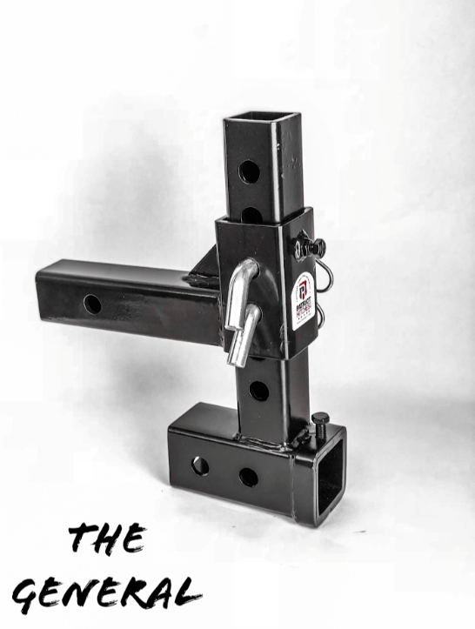
- Gross Towing Weight: 6,000 LBS At Max Drop.
- Gross Towing Weight: 8,000 LBS At Min Drop.
- Tongue Weight: 600 LBS At Max Drop
- Tongue Weight: 800 LBS At Min Drop
- Hitch Weight 15 LBS.
- Hitch Max Width 3”
- Overall Length: 11 ¼”"-
- Overall Height: 13 ¾”
- Shank Size: 2"

- 4 Pins (5/8) And 4 Clips Included

