“The Captain” By Patriot Hitches, LLC - Specifications

- Ball And Accessory Mount
- Meets Or Exceeds J684 SAE Testing Standards
- Ideal For Marine, Agricultural, Recreational And Of Course - Military Use
- Adjustable - 5 Way / 3 Balls, D-Ring, Pintle Hook
- Accessory Attachment Option - (See "The Private" Accessory)
- Lifetime Warranty
- Sturdy Steel Construction
- Black Powder Coat Finish Resists Rust And Corrosion
By The Numbers….
- Fits 2” Inch Hitch Coupler
- Fits 2 ½” Inch Hitch Coupler (With Reducer Insert)
- Our Tri-Ball Mount Fit Class III/IV 2 Inches Hitch Receivers
- 12 ½” Inch Length Hollow Shank
- 17 ½" Overall Length With D-Ring Extended
- Overall Height: 6 ½“
- Overall Width: 7 ¼“
- Hitch Weight 18” LBS
- Shank Size: 2"
- 2 Pins (5/8) And 2 Clips Included
- Three Attached Chrome Trailer Hitch Balls:
- 1-7/8 Inches / 350 Lbs. Tongue / 3500 GTW
- 2 Inches / 600 Lbs. Tongue / 6000 GTW
- 2-5/16 Inches / 1000 Lbs. Tongue / 10000 GTW
- Attached Heavy Duty Silver D-Ring
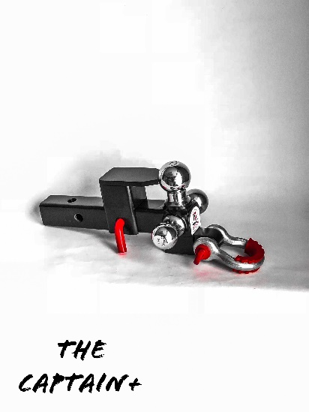
- (¾” Round Shackle) / 8000 GTW
- Removable - Pintle Hook Accessory – Can be removed and
stowed on bottom side of hitch with NO interference.
- (2 5/16” Ball) / 10000 GTW

