Panel 1 –
- Make logo smaller (50% smaller)
- Make circle on phone a square shape
- Take out “amazing technology” bullet point
- At first, we couldn’t tell that there was a blue brain on top of the girl’s head – we thought it was a scarf. Can you please make it more obvious that it is a brain? Maybe make it a flesh color instead.
- Make bullet point that says “protect you and your loved ones today” – change to “Protect You and Your Loved Ones from Toxic Radiation”
- Take 5 circles off the bottom (circles with appliances)
- Put made in USA flag in the upper right hand corner

- Make paragraph a larger font – the paragraph that says “infused with over 30 homeopathic…”
- Delete last sentence in paragraph that says “they neutralize the effect that they have on the body.” – change it to – They “neutralize” the damaging effects that EMF radiation has on the body by introducing healthy, balancing frequencies.
- Contains 10 Neutralizers – put across bottom
- Instead of saying “advanced technology” in gold circle, please say Doctor Created
- Put as seen on tv picture on bottom –

Panel 2 –
- Under logo say “Visit Website for Video on Best Ways to use this Product”

- We would like to put a chart on the back of the box explaining how many EMF neutralizers need placed on different designs. We would like to have an abstract image of examples. In the chart, we would like to have this data with graphic images -

- cell phone - 2 EMF tags on back
- laptop - 4 EMF tags on bottom corners
- Desktop computer - 2 EMF tags on monitor, 4 on tower
- vacuum - 2 EMF tags on handle
- small appliances - 2 EMF tags on both sides
- microwave - 2 EMF tags on both sides
- Television - 4 EMF tags on back corners
- Hair appliances (dryer, curler, straightener) - 2 EMF tags on flat surface

- GRAPHIC PICTURE IDEAS INTERESTING FACTS:

*Doctors are now aware of breast tumors directly where cell phones are placed
*Using a cell phone for more than 4 hours per day reduces sperm count by 25%
*Lap tops are more dangerous than cell phones
*Using your cell phone for 2 minutes affects the DNA of the brain for over 1 hour after use
** Here are some picture ideas –

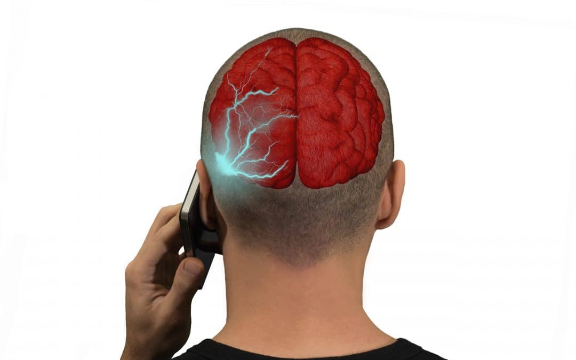

Panel 3 –

- Have a picture of happy people smiling –


- Have thought bubbles coming out from around the people with testimonials –
- When I watched the muscle testing video and did the test, I was much stronger with the EMF tags
- While talking on the phone, my ear feels less hot
- After 1 week of using the tags, I can honestly report that I’m sleeping much longer and deeper
- The neutralizers are reducing my migraines, that I usually get while on my phone
- My fatigue has significantly decreased since I started using these tags
- When I put the tags on my grandchild’s phone, she immediately became less moody
Panel 4 –
- Put emftag logo on top
- Picture of guy on a laptop showing EMF waves coming off laptop like this – but it needs emf waves coming off laptop


- Put key features on it –
- Easy to apply
- Neutralizes the damaging effect EMFs have on the body
- For Use on Cell Phones, Computers and all electronics that are in close proximity to the body
- Improves Sleep
- Calms Nerves
- Calms Emotional Disturbances and Mood Swings
- Slim Design

- Put this paragraph on it –

Long-term exposure to EMFs have scientifically proven, long-term, negative effects on the body. From tumors, headaches, irregular heart rates; memory decline, impotence, infertility, miscarriage, emotional outbursts, thyroid disorders, blood cancer, cancer tumors, fatigue, cardiac issues and dementia, the impact of EMF’s on the body can be horrifying and devastating.

EMF Tags WILL NOT CHANGE EMF meter readouts. This is a misconception. If they totally blocked the EMFs, your device would not work. EMF Tags are infused with homeopathic frequencies which help to neutralize the damaging effects that EMFs have on the DNA of the body by exposing the device to a balancing frequency.

- Leave a square space on the back for a barcode (we do not have the barcode yet)

