Brand name EMF Tags
Website: EMFTags.com
Logo – Attach emftags_box.png and emftags_box_new_white.jpg
Also attach die cut lines pdf file
Colors - We like the colors of sky blue and green

See Website for Video on Best Ways to Use EMF Tags and Read Customer Reviews

Bullet Points:
Protect You and Your Loved Ones Today
Amazing Technology
Easy to apply
Neutralizes the damaging effect EMFs have on the body
For Use on Cell Phones, Computers and all electronics that are in close proximity to the body
Improves Sleep
Calms Nerves
Calms Emotional Disturbances and Mood Swings
Slim Design
Infused With Over 30 Homeopathic Frequencies to Neutralize the damaging effects that EMF’s have on the human body. The frequencies that are infused in the EMF Tags help to reduce the haywire that is caused when EMF frequencies are exposed to the body. EMF Tags will not block the EMFs (or your device would not work) – they neutralize the effect that they have on the body.

GRAPHIC PICTURE IDEAS INTERESTING FACTS:

*Doctors are now aware of breast tumors directly where cell phones are placed
*Using a cell phone for more than 4 hours per day reduces sperm count by 25%
*Lap tops are more dangerous than cell phones
*Using your cell phone for 2 minutes affects the DNA of the brain for over 1 hour after use
*Children’s brains absorb 10 times as much radiation of adult brains

Testimonials:

--- We would like to put a chart on the back of the box explaining how many EMF neutralizers need placed on different designs. We would like to have an abstract image of examples. In the chart, we would like to have this data with graphic images -

cell phone - 2 EMF tags on back
laptop - 4 EMF tags on bottom corners
Desktop computer - 2 EMF tags on monitor, 4 on tower
vacuum - 2 EMF tags on handle
toaster - 2 EMF tags on both sides
microwave - 2 EMF tags on both sides
Television - 4 EMF tags on back corners
Hair appliances (dryer, curler, straightener) - 2 EMF tags on flat surface

--- On front of package, we want an American flag graphic and words that say "originated in USA"

--- On front, please put "Created by Board Certified Natural Integrative Doctor, Valerie Nelson"

**Important: These Do Not Change EMF Meters – These are homoepathic “neutralizers”, not “blockers”

Long-term exposure to EMFs have scientifically proven, long-term, negative effects on the body. From tumors, headaches, irregular heart rates; memory decline, impotence, infertility, miscarriage, emotional outbursts, thyroid disorders, blood cancer, cancer tumors, fatigue, cardiac issues and dementia, the impact of EMF’s on the body can be horrifying and devastating.

EMF Tags WILL NOT CHANGE EMF meter readouts. This is a misconception. If they totally blocked the EMFs, your device would not work. EMF Tags are infused with homeopathic frequencies which help to neutralize the damaging effects that EMFs have on the DNA of the body by exposing the device to a balancing frequency.

**We are going to add a few one sentence testimonials here**

Also put ‘Made in the USA” and As seen on TV badge that we earned. –



Client Reviews – put somewhere on package please
- When I watched the muscle testing video and did the test, I was much stronger with the EMF tags
- While talking on the phone, my ear feels less hot
- After 1 week of using the tags, I can honestly report that I’m sleeping much longer and deeper
- The neutralizers are reducing my migraines, that I usually get while on my phone
- My fatigue has significantly decreased since I started using these tags
- When I put the tags on my grandchild’s phone, she immediately became less moody
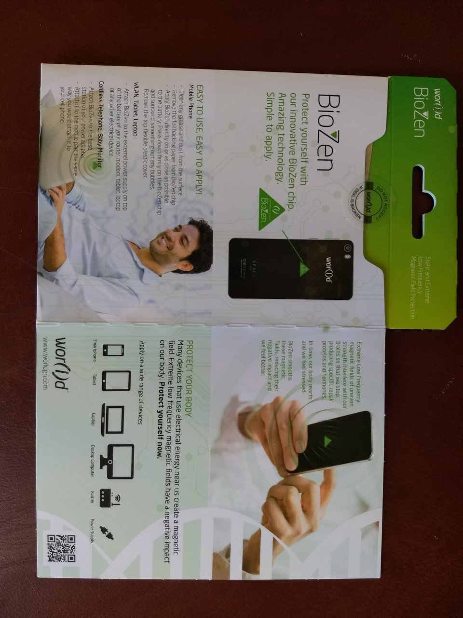
We like these package (just for some ideas about the type of look/graphics we are wanting) –

