PB take a look at this
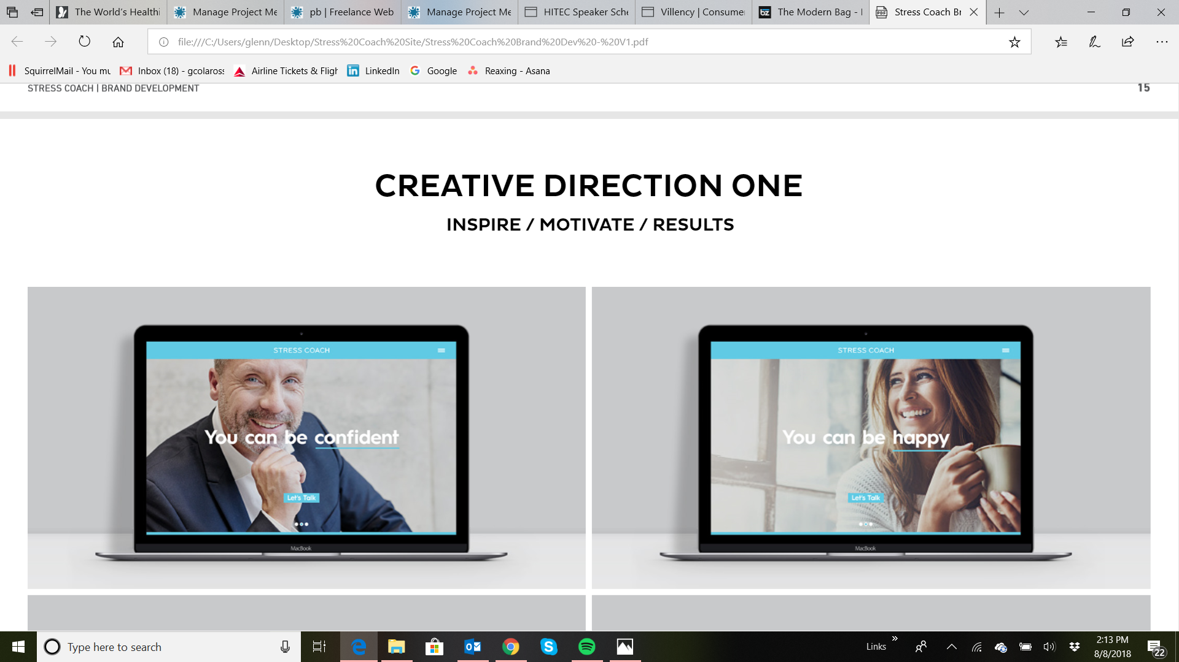

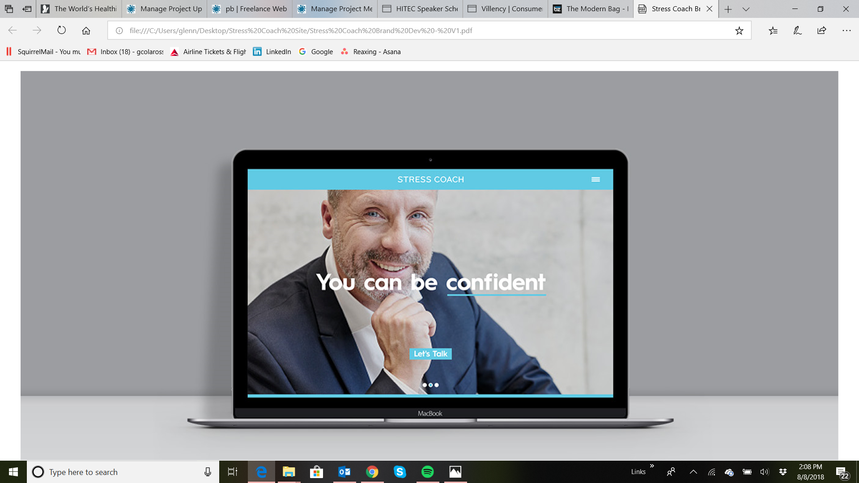

Also this…The S & the C in the actual logo, not the word stress coach, two different colors and then change the words to the opposite colors

