Stress Coach WebSite direction
INSPIRE / MOTIVATE / RESULTS
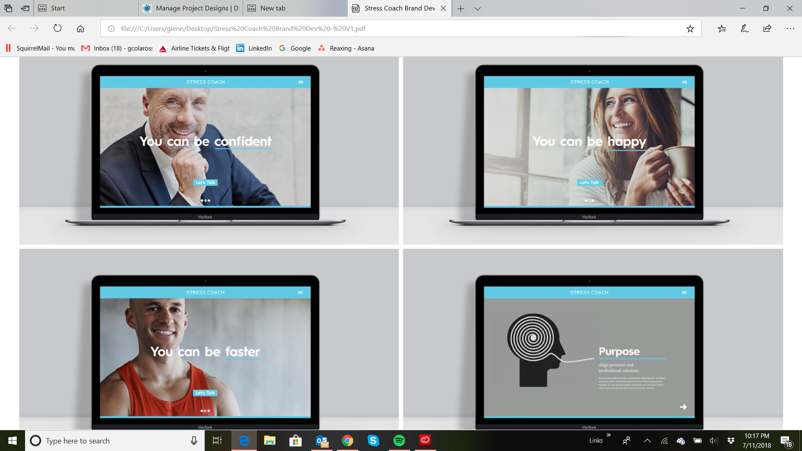

Another direction
TRANSPARENT / PROCESS / SUCCESS

See below
