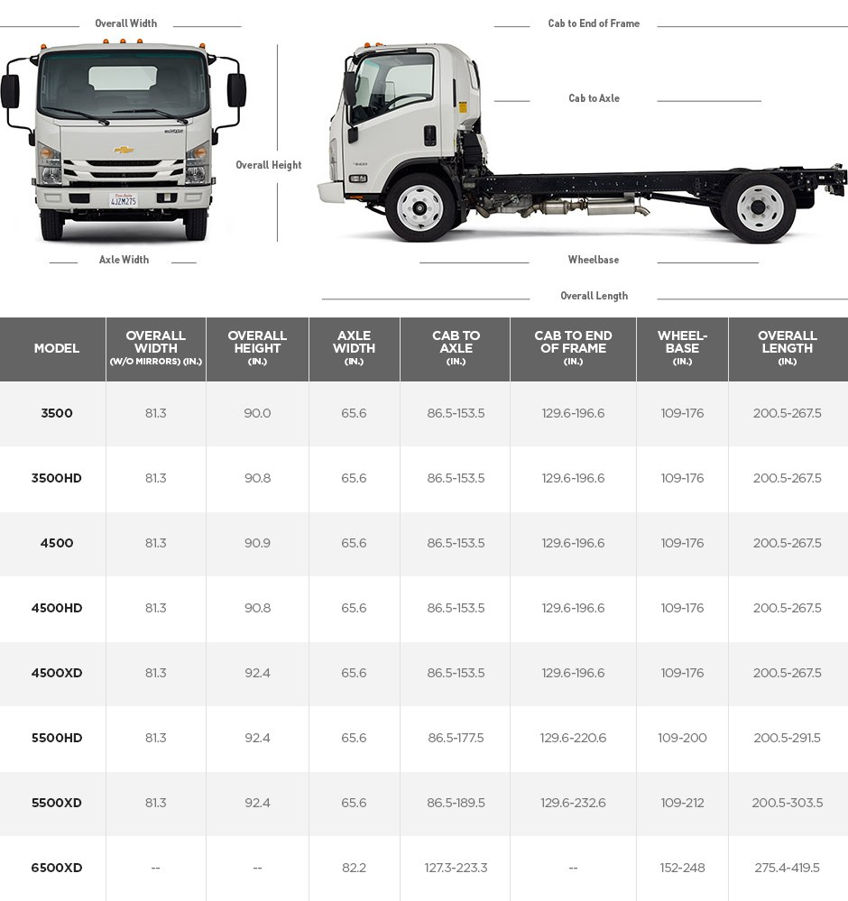

Chevy 6500XD
- Battery-electric vehicle
- Fast, smooth and quiet
- Maintenance performed by Ryder or trained local dealers
- Vouchers and grants available for vehicle and charging
- Tilt cab for convenience in maintaining
- 22 1/2-inch wheels and tires
- Standard air brakes
- Rear multi-leaf springs; front tapered leaf springs
- 90-degree wide-open front doors
- Wide entry step with cornering lamp
- Regenerative braking

Base Chassis Class 6 Low Cab Forward Truck
GVWR 25,950 lbs
Electric Range 110 miles
Electric Vehicle Supply Equipment (EVSE) J1772 with CCS Combo for DC Fast Charge
Bi-Directional Hardware Bi-directional onboard charger- DBC-Series 6.6kW
Availability Deliveries beginning in Q4 2018
Battery Capacity 160 kWh
Battery Manufacturer LG Chem (prismatic cells)
Charge Time 20 hours (level 2) 3 - 4 hours (DCFC)
Maximum Speed 65 mph (electronically limited) 77 mph without governor
Peak Power 220 kW (295 hp)
Torque Rating 700 Nm (516 Ft-lbs)
Warranty Base Chassis: OEM standard warranty
EV Conversion: Lightning Systems standard warranty (Powertrain 5 year / 60,000 miles)
Options • DC Fast Charge (50kW) • Analytics (predictive maintenance, route scoring, range analysis, driver behavior, geofencing

