Design Brief
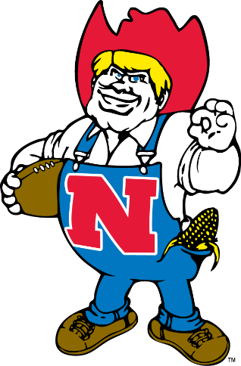
- Herbie with

- The skull and football helmet instead of Herbie’s head and hat.

- His arms as demonstrated in the picture below.

- I would like 2 versions the original Herbie and a modernized Herbie.

Thank you!
