Beyond Body Wraps

July 4, 2018

Project: Logo design for Beyond Body Wraps

Background:

We are starting a new retail body wrap and health spa store in Huntington Beach, California. Our goal is to help people:

- Lose weight
- Lose inches
- Tighten their skin
- Detox
- Combat the aging process
- Relieve pain

We do this through offering treatments such as:

- All natural, organic beauty treatments including collagen oils, masks and lotions
- Body wraps treated with organic, all-natural vitamins and minerals we wrap customers up in and place under an ultraviolet heating blanket (helps detox body, reduce inches)
- Firmasculpt treatments that helps breakdown fat, reduce inflammation and maximize weight loss
- LED light beds that help increase healing process, reduce wrinkles and aging spots
- Detox teas
- Weight loss programs
- Skin tighten (non-surgical facelifts, 24k facials, etc.)

Audience:

- Mainly women, but more and more men are using spas to reduce inches and manage weight and pain
- We are targeting 20 – 65 years old

Look and Feel:
- We are in Huntington Beach, so we want something hip
- Contemporary font – not a script font, I like san serif fonts
- We want something fun, high energy, but we are offering all-natural botanical oils, lotions and solutions for our treatments (you cannot buy this online or in the stores as we make it fresh daily) … so we want it to feel natural, like a whole foods store or think classy hippie - Bohemian
- I love Picasso’s surrealism period – I want this store to feel different, creative, when you see our materials they stand out … fun, creative, cool, sophisticated in an edgy way NOT conservative

Ideas:

Think Picasso

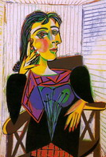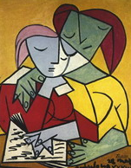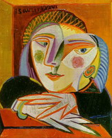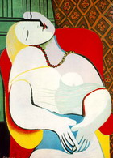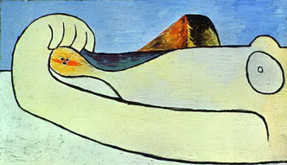

Meets Bohemian:
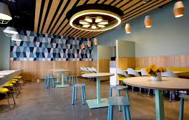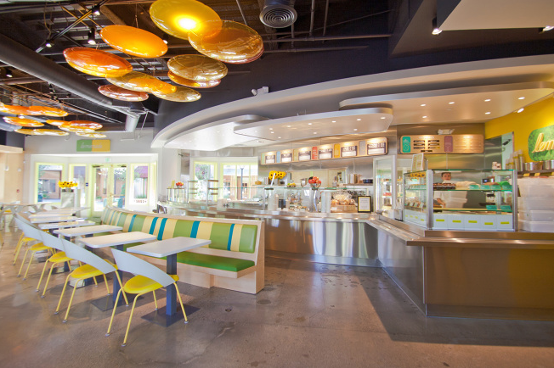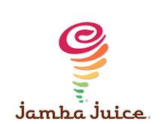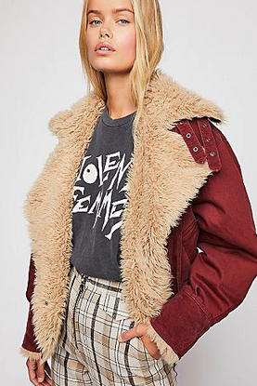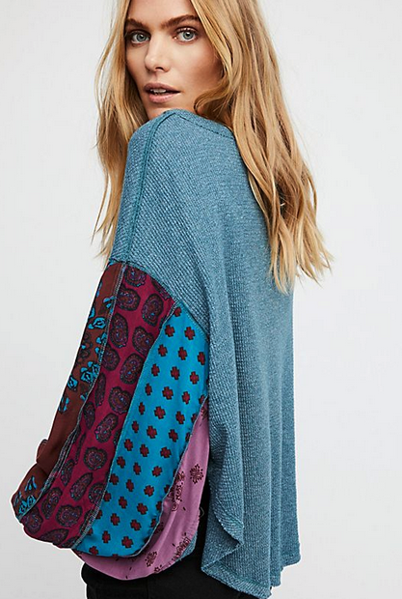

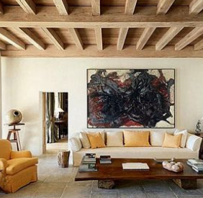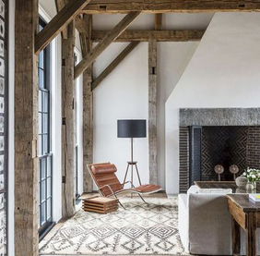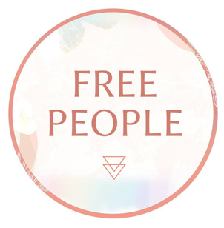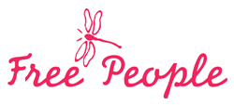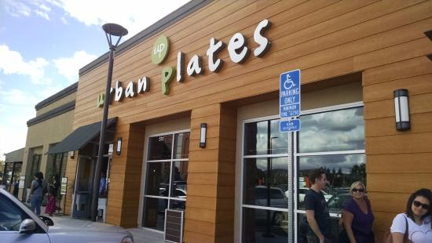

Requirements:

- Need the font in an eps, ai and jpg format
- If you are using a specific font, I want to know the font and if you iterate on a font, I still want to know the font
- This needs to work for a storefront sign – I want it to pop as well as in print and online

