“Master Lace” Design Brief

Ask: Logo and wordmark for luxury men’s accessory brand. We’d also like to identify a good matching font that we can use for packaging, marketing materials, etc. (A full branding guide may be required further in the future but for now we just need logo and wordmark to launch.)

Brand Identity: Turn of the 20th century gentleman style:
- Top Hats, curly mustaches and Monocles.
- Men’s Dandy Style a la Great Gatsby or imagine an “Adventurer Society" like Around the World in 80 Days.
- Logo should reflect this serious high society luxury but lend itself to subversive tongue-in-cheek humor (since we will be playing with the fact that it sounds like “Master Race” in the cheeky, humorous marketing campaigns).
- Could potentially look like a coat of arms that a tailor to British Royalty (e.g. Savile Row) would hang outside their “shoppe”.
- If we can work an actual shoelace into the design (e.g. the leg of the "R" in "Master" curls off into a shoelace that would be cool.

Logo should be high contrast black silhouette so that it will look good if it's engraved or laser-etched into wood since I'd like to make some nice wooden display boxes for in-store sales. We’re also going to be potentially engraving the logo or wordmark onto metal aglets (i.e. lace tips) so we’ll want the logo in a vector format so that it can easily scale up or down depending on size/detail for engraving.

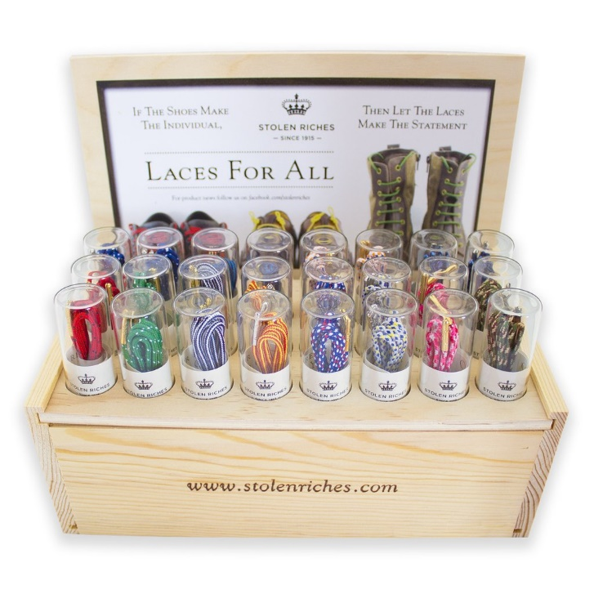
e.g. Stolen Riches’ Wooden Display Box for in-store sales.
Competitors: Main competition is stolenriches.ca. They have their shoelaces in Harry Rosen and Holt Renfrew. Going to copy and improve on a lot of what they are doing. We want it to be clear that we’re in the same luxury price category as Stolen Riches but not completely ripping them off.
Another brand is glititaly.com that have really fancy leather laces. But we’re going closer to Stolen Riches for our branding.

Potential Design Inspirations:
