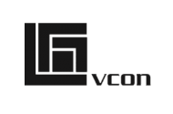
-I like the strong logo icon used and the strong font even though lower case used

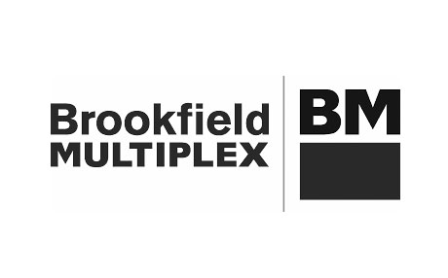
- Strong text here. I would explore more creativity with type of text

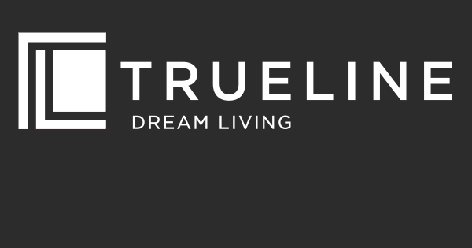

- Strong icon with clear text. Text could be stronger

