I like the strength of the font and the way the “B” flows into the “F” and the dark background and light font.

I do like the “e” in the negative but not with use of wings as object. I also like the strength in this font.

I don’t like the overlap of the 2 letters as I think it can be too confusing to read.

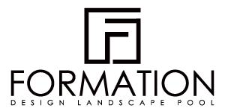

I like the use of the logo and the layout of logo and Text. The link with the text in the logo is also very creative.
This reversed may be too simple but effective as a logo or something I can use on clothing. This may need “Beyond Form Building Group” under.

I like the way the letters are not extremely obvious here but you know what they are. Reversed “B” can maybe used here?



This has strength even with lowercase

