Human Donald (Don) Truck profile

Donald Truck is 48 years old and has been working in the trucking industry since he was 20 years old. Don is male with a fit body and 5 feet and 10 inches tall. He lives in Texas or in a southern state and his skin color is neutral (between white and brown) and has brown eyes. His left arm is more tanned than his right arm due to long driving hours and sun exposure. He has brown hair color. He has hair in his arms and chest and a moustache. He has a light beard since he hasn’t shaved in weeks (otional). He has short hair although he has longer hair in the back part of his head. He wears a short sleeve shirt with DonTruck’slogo on the front pocket and wears white t-shirt under his shirt.

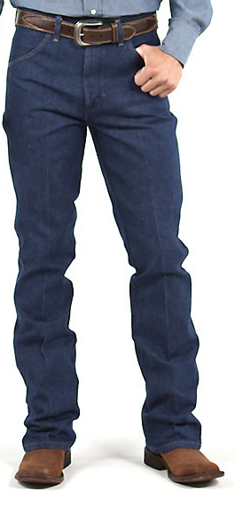
He wears blue jeans and a large belt plate and cowboy boots. He has a trucker’s cap like the one below (the cap must be NEITHER red nor blue and has the DonTruck logo in the forehead)
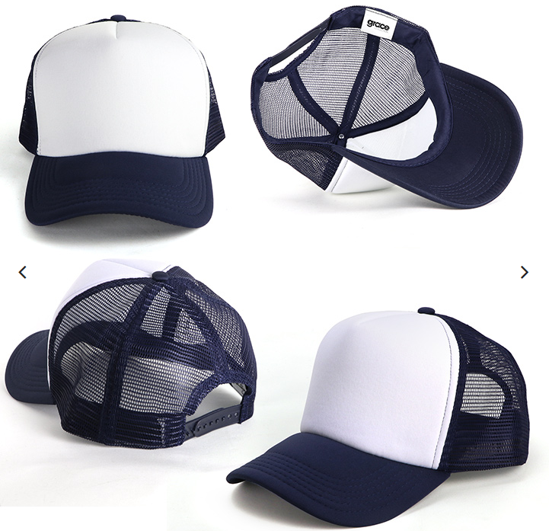
Donald Truck uses a hand free device as the following:
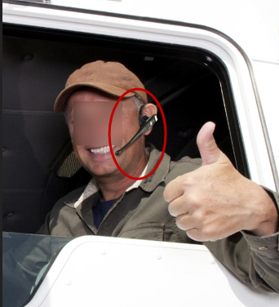

Donald Truck is adventurous, very kind, smiley and positive although he is kind of introvert. He copes very well under pressure and enjoys solitude. He is very helpful and he is always willing to help others personally and on the road. His colleagues and friends consider him as a road “angel”.

Likewise he is much disciplined in his day to day chores. He is good looking and flirty.
Donald Truck manages technology very well, he know about all the trucking industry processes and manages his business very well. He knows how to make the most out of his intelligent cell phone. He does his banking online and he does videoconferencing to get ahold of his family from afar. He also uses his cellphone to play music and as a GPS. To Don, is cell phone is more than a mean of communication, it’s a working tool.

Donald Truck is married and has three children. He has a good relationship with his wife. His children are 24, 21 and 17 years old. His elder son works with him driving one of his trucks. His 21 years old son is currently applying for the CDV (Commercial Driver’s License) and his youngest daughter who is 17, is a senior at high school. She wants to go to a public college in a southern state and apply for a Business Administration bachelor degree to help his father run the business.

After graduating from high school, Don studied to become and automotive technician. He worked as such for three years. Don Truck started his career as small truck driver when he was 20 years old. He has always liked trucks since he was a kid. He was always intrigued about trucks when he drove with his father on the highway on the family truck Ford 150). He always asked his father what load did the trucks were carrying and where they were going. That was a question he frequently asked his father. When he became 21 years old and thanks to his effort and his will to move forward, he got his commercial driver’s license which allowed him to drive bigger trucks. Don started working as a truck driver being in the road for several days (and months) at a time throughout the U.S.. Thanks to his discipline and ambition he managed to save enough money to buy his own truck. When he made more money, he managed to buy more trucks up to the point where he founded his own trucking company. He owns six (6) trucks. Don drives one of his trucks and at the same time, he is the owner of his own trucking company.

On his spare time he likes to go fishing.

Animal Donald (Don) Truck profile
Don Truck is a land animal with human traits. It represents intelligence, agility, honesty and closeness. His got great skill for computers, it is a digital native and he likes mechanics and engineering. Don is the truck drivers’ best friend; he knows about their processes, business and he loves technology.
Donald Truck is mid age (48 years old equivalent) and has established a strong bond with truck drivers since it was a teenager. He wears a cap as follows:
Donald Truck is adventurous, very kind, smiley and positive although he is kind of introvert. Likewise he is much disciplined in his day to day chores. He is good looking and flirty.
Donald Truck manages technology very well, it knows all its processes and it provides good advice to the drivers and businessmen in the trucking industry. He knows how to manage technology and has an unlimited cell phone plan. Don does his banking from his cell phone, and he manages to communicate with his family through videoconferencing from afar. He uses serval apps to support his business. He also uses his cell phone to play music and to navigate (google maps). His cell phone is much more than a mean of communication, it’s a working tool.
On his trips he usually take photos and videos from the North American landscape. It publishes its photos and videos in its personal blog.
Reference character:
