Dear PB
Hope you are doing well.
All pages you have designed totally different from each other. Please consider following comments.

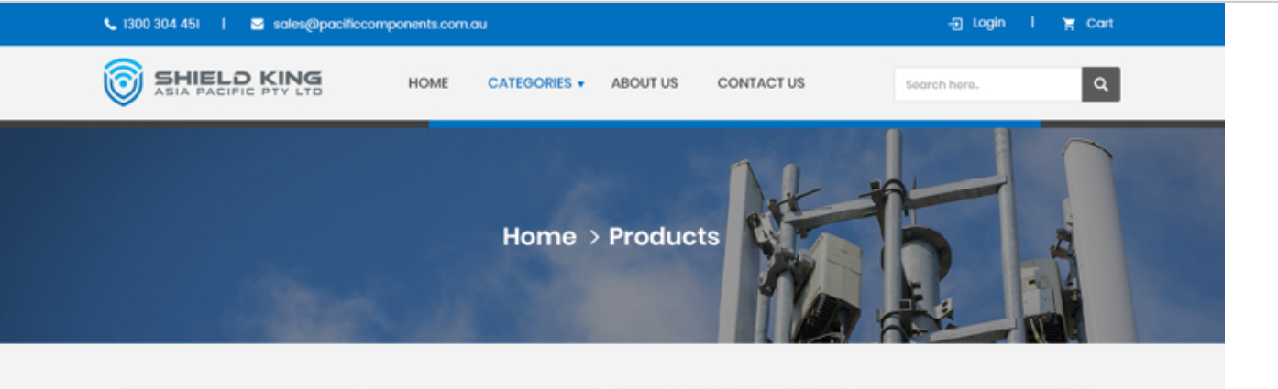
Figure1
- Please use this header(Figure1) for every page and please with the NAVIGATION (in banner) also. Please put navigation some where else and make it hyperlink.
- Please change this header. Please change following thing:
- Make Search Bar more appealing.
- Don’t use Home is menu options.
- Shift About us and Contact us to the top Blue strip with Login. (so, we have more space for Search Bar)
- Please change the MENU to these three options(Figure2) and our MENU should be like this 3-layer(mentioned in pervious doc file) when you Hover on any category (please check http://203.170.87.225/~shieldki/shieldking_ecommerce/) please match this with design.

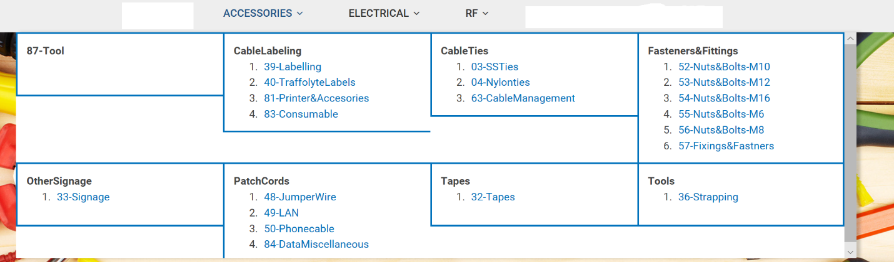
Figure2

- Design #19268969: we don’t need page for product view. We need a POPUP to display product on the same page and information about it.
- Design #19268970: please do note show categories in left and it’s in tabular form, please get rid of this also. We need our cart with pictures of products. (Figure3)
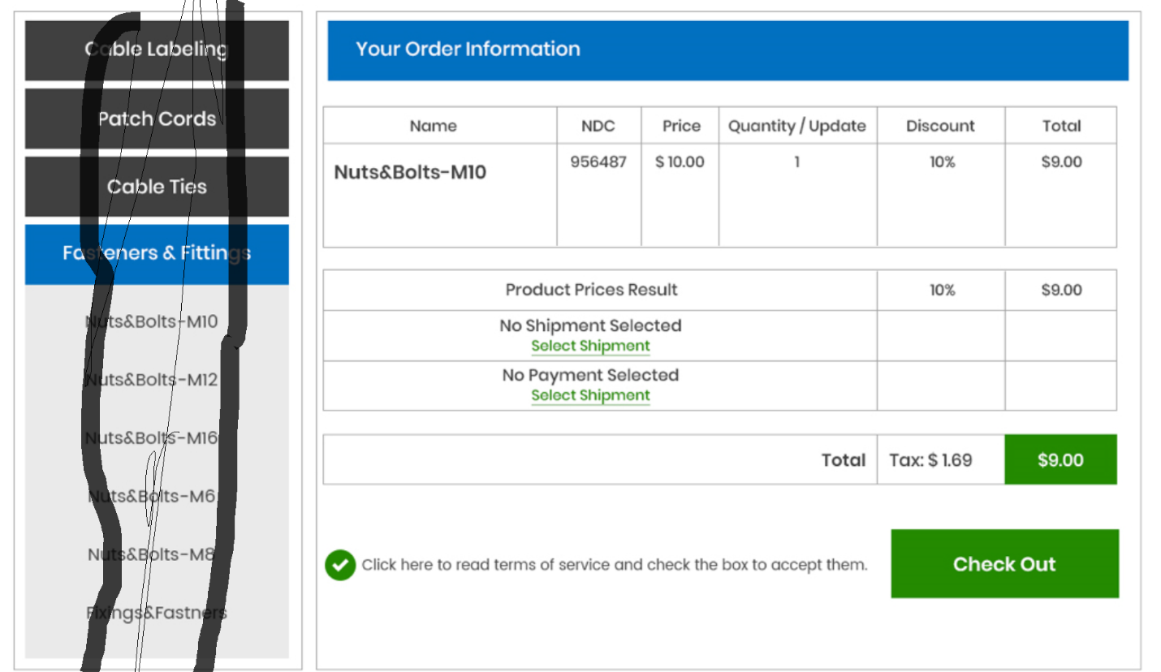
Figure3
- Design #19268971: please take it out from box (Figure4) and please use 3- layers category and please use break when finished with each category. Each page should contain 4 breaks (like show four category-2 on each page). If this is a category page, please do not show product here (no mean to Add to Cart button and price). We prefer grid view over listing.
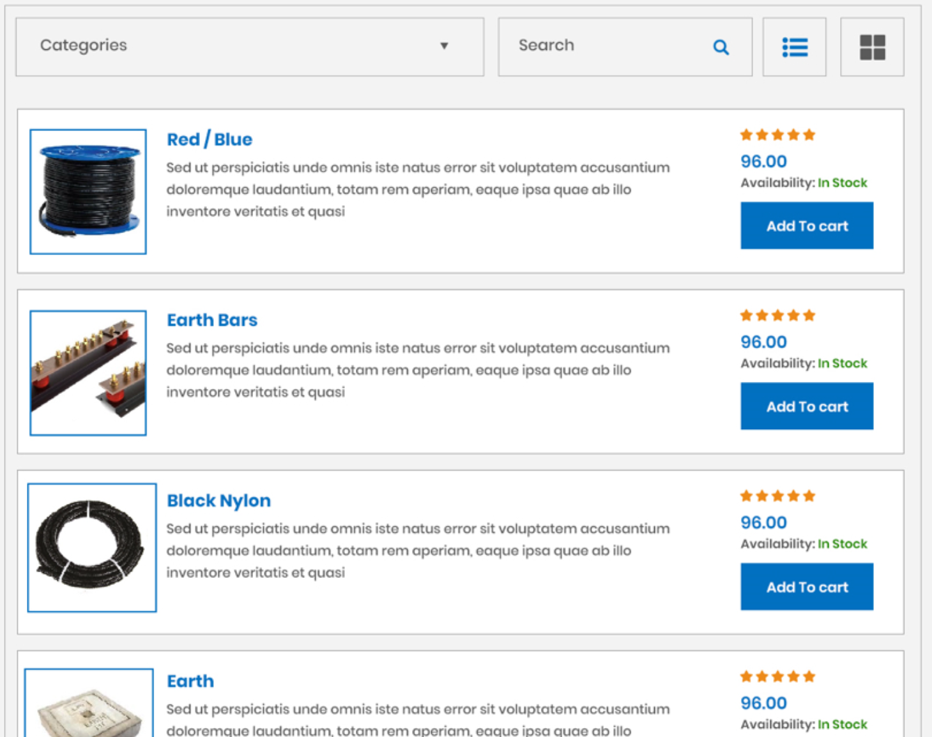
Figure4

- Design #19268968: please use break on product page and break should be category wise(Figure5a) and please use arrow buttons for next products in same category(Figure5a). There show be a Add to Cart Button and Quantity drop down with each product. (this will minimize the clicks.) and need a Bar to go to specific category (Figure5).
Figure5
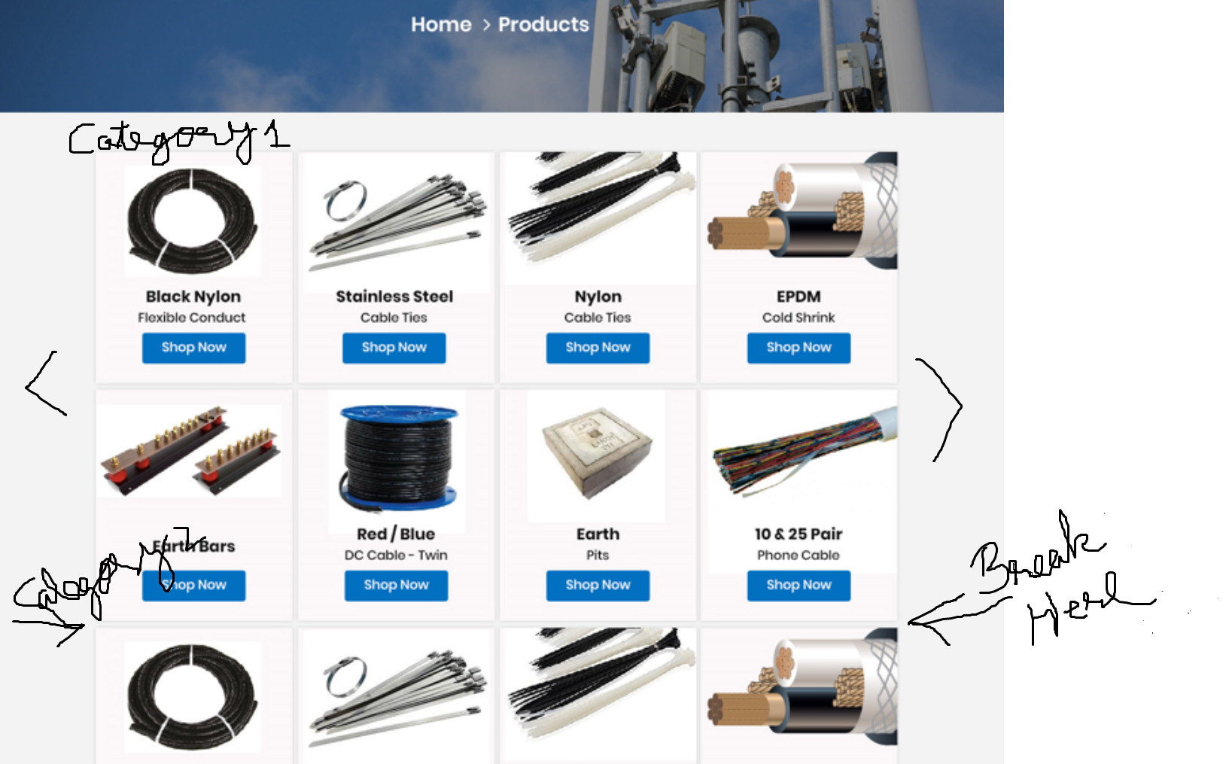
Figure5a
- Please fit location map in this (Figure6). May be truncate Call Now part and shift INFO to left.

Figure6
- Please put some link on both side empty space (Figure7) (like Policy, contact us, about us etc), text should be small so that it can’t hide background picture. Please make background picture more transparent.

Figure7
- Please make a Search page. If keyword matches a category, then only list the category but it matches a product then please show product with ADD to cart and Quantity options.
Thanks

