Layout

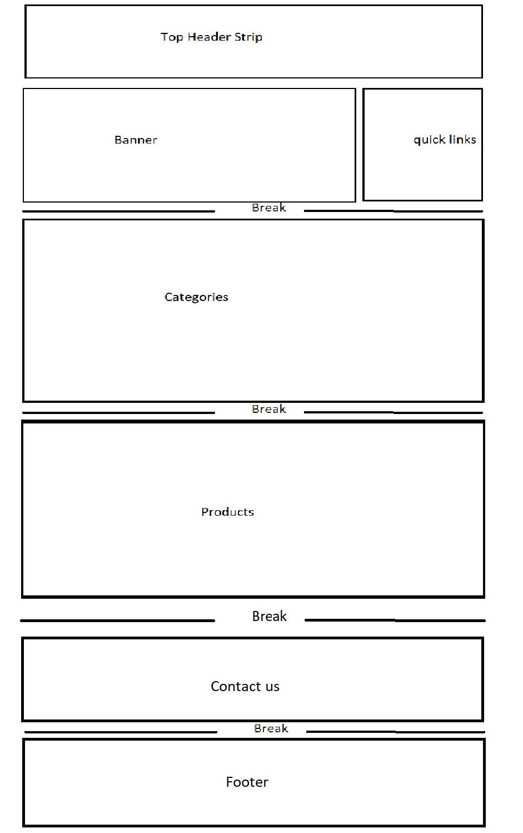

Top header strip
We like simplicity of this header and color scheme. If you need logo as well let us know. Please make Search bar more appealing. If you like rearrange About us and Contact us some where else. (menu items should be similar with http://203.170.87.225/~shieldki/shieldking_ecommerce/# )



Menu working
Please check Menu items at http://203.170.87.225/~shieldki/shieldking_ecommerce/# . we do not need much items. This is only for design.
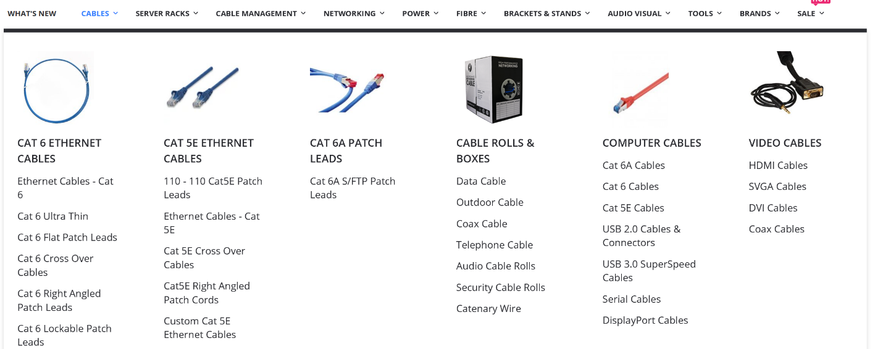

Design for Categories and also same for products
Please note that appearance should be matched with whole theme. This is a raw figure that’s what we need in website.
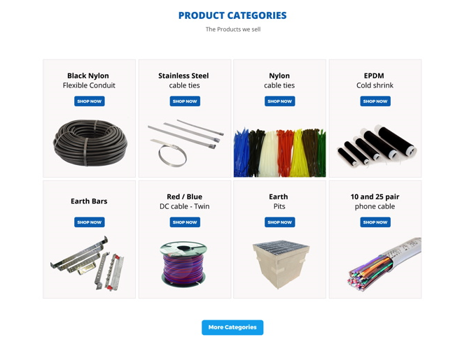

Products grid need some extra items in each product.
With product grid we need a quantity drop down and add to cart button with each product for minimize click.
Also need price here. Please manage this your self
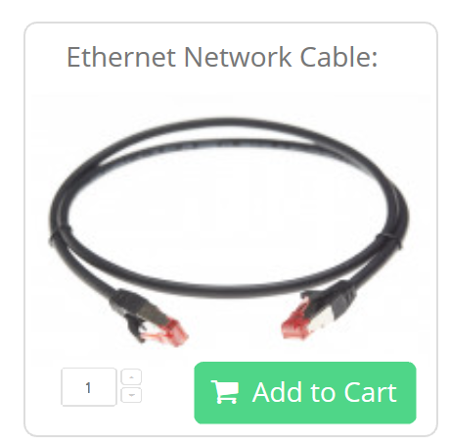
Breaks
Please try to fit this page break and see how’s we go. (or similar to this )
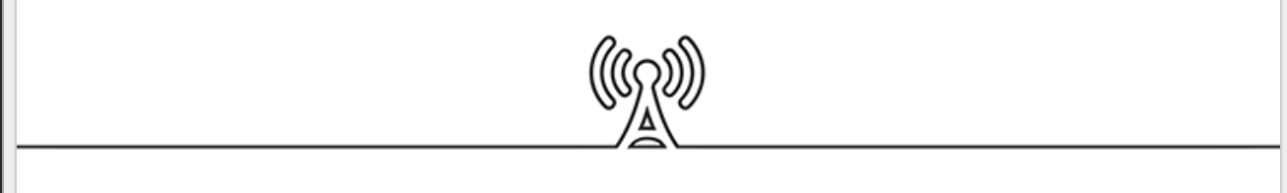
For more details please have a look at http://203.170.87.225/~shieldki/shieldking_ecommerce/#
These are some of similar websites for products and categories:
https://www.carroll.com.au/
http://www.pacificcomponents.com.au//category?catId=158
https://www.jaybro.com.au/
Pages
- Home
- Category level -2 view (when you click level -1)
- Category level -3 view with products (when you click on level -2)
- About us
- Contact us
- Cart view and checkout (we are using PayPal).
- Popup when you click on product on the same page. It should have pictures of product and details of products.
Basically, we have three level of Category menu
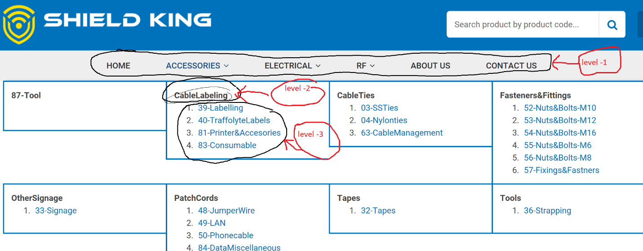
We are renaming our level -3 categories. So, do not worry about the numbers in level -3.
For Category level -3 view page we need a table like design for each category of products (screenshot).
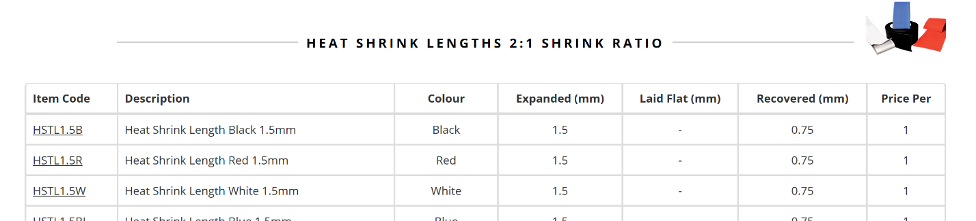
Note : we need also a photo column for each product in the listing. If we hover, size will increase. Like screenshot.
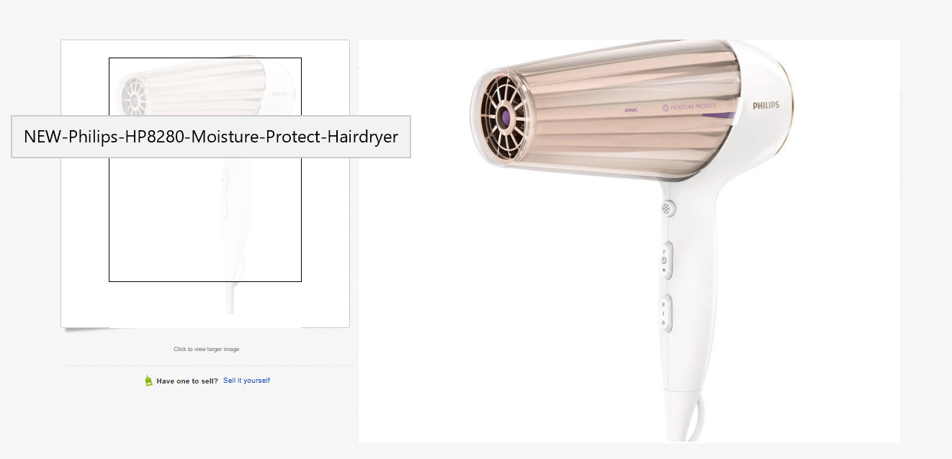



Looking nice and give telecom feel. May be something similar to this, used for footer.

