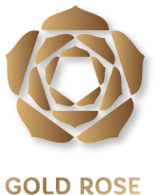

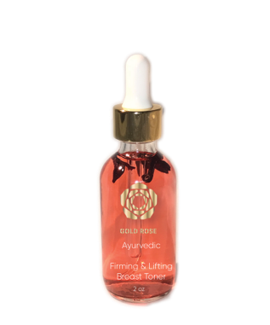
Gold Rose curates organic infused products where holistic skin care meets a luxurious experience. Each ingredient is carefully selected; providing Ayurvedic herbs, rich minerals & elements. Stimulating hydration and anti-oxidants to lift, firm and illuminate your skin. We believe in connecting with your inner mantra, stimulating higher vibrations, self-esteem, positive mind and soul. As a brand we work with our experts/suppliers of Ayurveda to ensure that our products meet the quality, wholesome healing that you need.
Gold Rose Product List

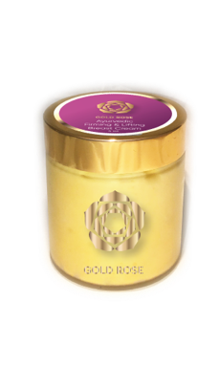
Gold Rose Firming and Lifting Breast Toner
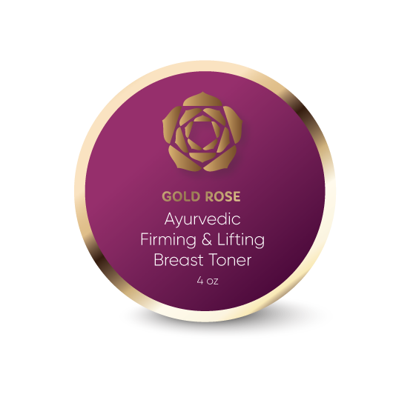
Using all natural Ayurvedic herbs, our breast toner, prepares the area for maximum absorption, giving you the best results and the most invigorating treatment

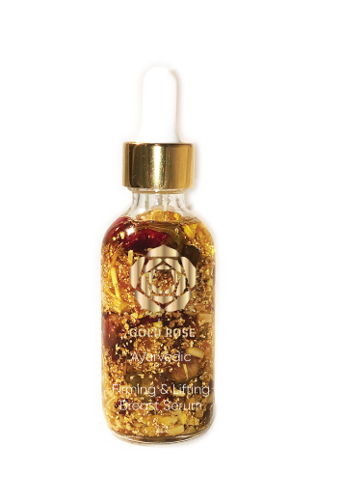
Gold Rose Firming and Lifting Breast Cream
Using all natural Ayurvedic herbs, our breast cream helps enhance, tighten, and lift your breast

Gold Rose Firming and Toning Breast Serum
Using all natural Ayurvedic herbs, and a touch of 24k gold, our serum enhances the experience and quality of results when partnered with the Gold Rose Firming and Lifting Breast Cream providing an all-day boosting experience

