About Us: TALENTCHEETAH is an online talent marketplace dedicated to connecting Businesses with Freelance Project and Program Management Experts. WE ARE FAST. SPEEDY.

Positioning of cheetah and text: See example below. (Note: Cheetah does not have to be black or filled in with color. I prefer a vector. Something simple and with not too much detail. Be creative! Please do not point tail of cheetah up or curled). No cartoons or “cutesy” faces. No mean or fierce cheetahs or cheetahs showing their teeth.
Text: TALENTCHEETAH The word “TALENT” IN ORANGE AND the word “CHEETAH” IN GREEN.

TALENTCHEETAH

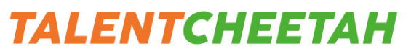

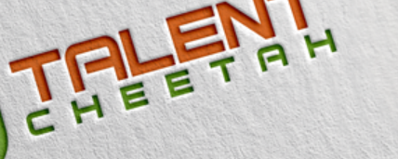

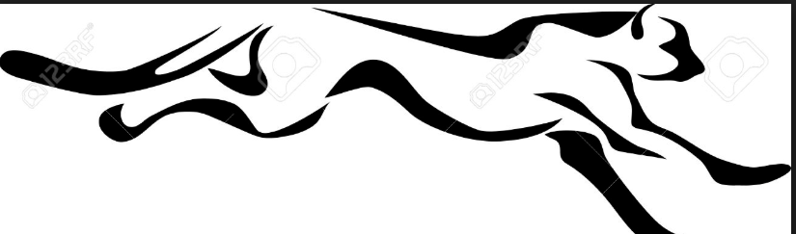

Font / Lettering: Easy to read font. Creative font—not easily duplicated. TALENTCHEETAH is one word.
Text Colors: The word “TALENT” in ORANGE and the word “CHEETAH” in GREEN.
Colors: Orange and Green, like the colors below. We would like to integrate these colors into our logo. Maybe green grass? NO Gradient colors, please.

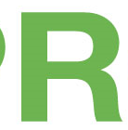

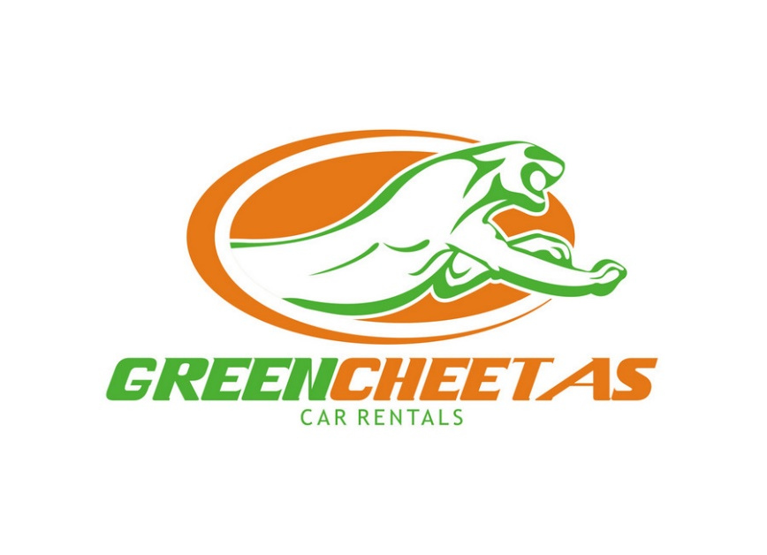
Additional Logo Requirements:
- TALENTCHEETAH
- Should incorporate a cheetah animal. Line down his eye like a cheetah would be nice. See below.
- 

- Not a scary, fierce one. No scary teeth.
- Looking for a very simple design.
- Creative and distinctive font, not generic font.
- Nothing too complicated with a lot of detail because the logo must transfer well for all collateral types. Business cards, website, brochures, etc.
- Looking for a unique design that we can trademark so please be mindful of not being too generic or of copying a vector online exactly. We will not be able to select your design.
Our Brand attributes:
FAST like a cheetah. We enable clients to hire quickly and easily.
Professional Project and Program Managers
Freelancers
FAST
Easy
Speed
Trustworthy
On Demand
Talent Marketplace
Connect
Match
Unite
Partner
Bridge
Reliable
People
Flexible
Elite
Cost effective
High Customer Satisfaction
Connect / Match
Project Management

