

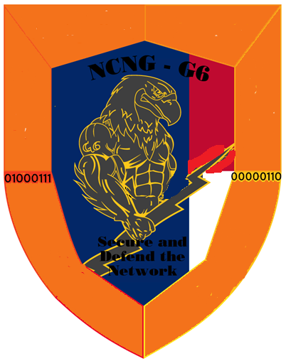
The Network

Defend

Secure and

The Network

Secure and

NGNC – G6

Security

OPS

OPS

Network

Management

Information

Service

Support

Mission

Command

Support

Information

