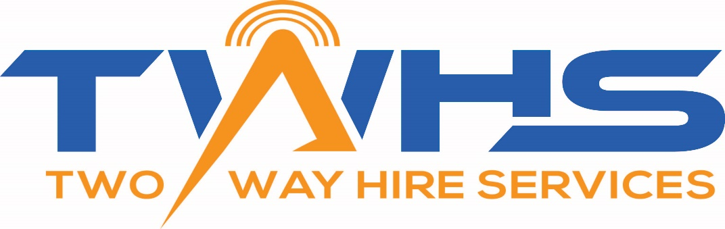
20% off your initial purchase or hire
HIRE
SALES
SERVICE

Stay connected with TWHS
We have stock all the major brand in Two way radios:
Motorola- digital and analogue
ToooAIr- National wide coverage
GME- CB radios, Antennas and accessories
Vertex standard- Commercial Two way radios
Kenwood- Commercial Two way radios

We do the small things that matter- programming, same day delivery options and custom-made equipment cases

Call Today for your free quote:
0418 459 210
Find us on Facebook
www.twhs.com.au



