Insight Capability Statement Examples

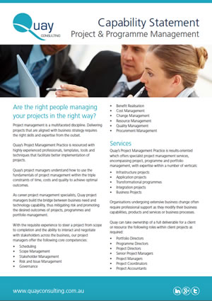

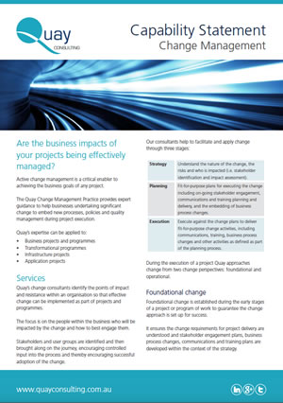

Insight Project Services Ltd is a leading project control consultancy based in Co Cork Ireland

For over 20 years we have been helping our clients to deliver complex projects and programs throughout mainland Europe.

We are passionate about empower organisations to achieve their objectives, on time and on budget.

We are continually innovating, evolving and learning, utilize the latest industry tools and techniques to deliver real value to our clients.

Our goal is to make successful project delivery more achievable and repeatable.

Insight Project Services are happy to provide

Planning and Scheduling
- Tender Planning
- Interactive Planning / Pull Planning
- EPCMV Planning & Scheduling
- Schedule Earned Value Management
- Independent Schedule Quality Assessment
- Schedule Risk Analysis (Monte Carlo)
- Planning & Scheduling Training

Management of Risk (M_o_R)
- Risk Management Policies & Procedures
- Risk Management Strategy
- Risk Registers
- Risk Improvement Planning
- Risk Response and Communication
- Risk Management Training

Cost Control:
- Estimating & Forecasting
- Change Management
- Earned Value Analysis
- Progress Reporting
- Cost Risk Analysis













