No braggin’ unless you’re draggin’
Perfect
DEER-DRAG

MULTUS DEER-DRAG
www.MultusProducts.com

Suggested Retail: $14.95

Dealer Price: $8.97 per unit

Benefits Why are we the Best Deer Drag?

Easy to Use Wrap, cinch down & Pull. Multipurpose use for large and small Game.

Fast Attach Attach to antlers, legs, neck or
& Release head of most wild game.
*Safety reflective strap

Back & Joint Saver Allows best position when dragging
lifting, or pulling to reduce injuries.

Compact & Fits Locking removable peg allows
In Your Pocket hunter to change straps, ropes or cable.

400 lb. Capacity Combine several units for dragging larger loads

Directions: Pass handle thru loop opposite handle, cinch down and pull.

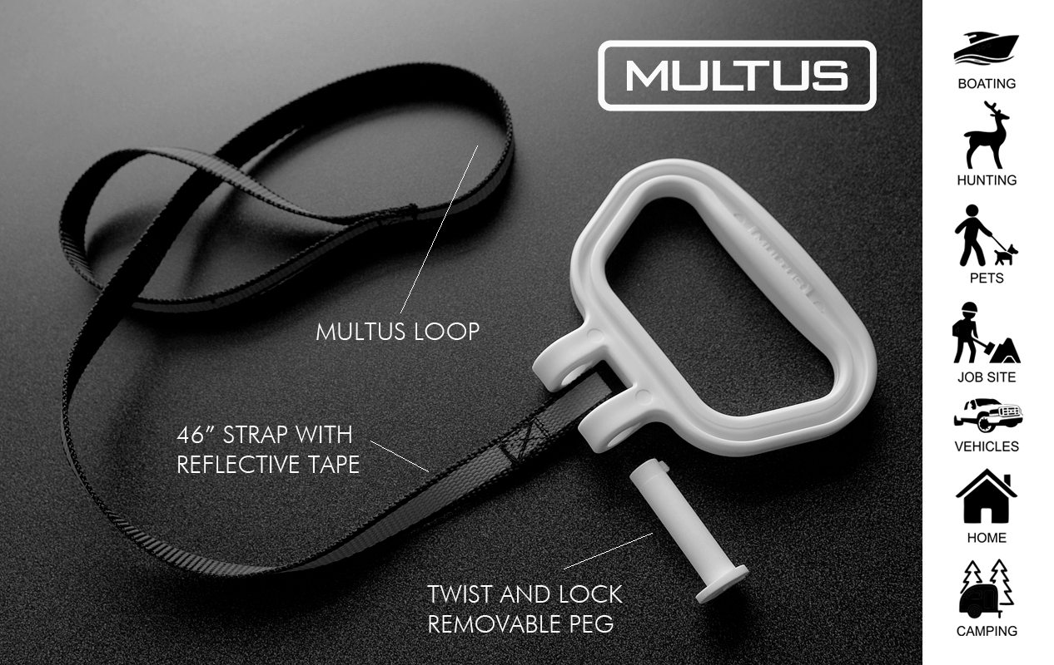

Patent Pending Caution: Do not use in overhead applications
Made In China nor to secure human weight.

Website: MultusProducts.com
Owner: Joe Porche
Email: MultusProducts@gmail.com
Contact: 504-251-3615

