
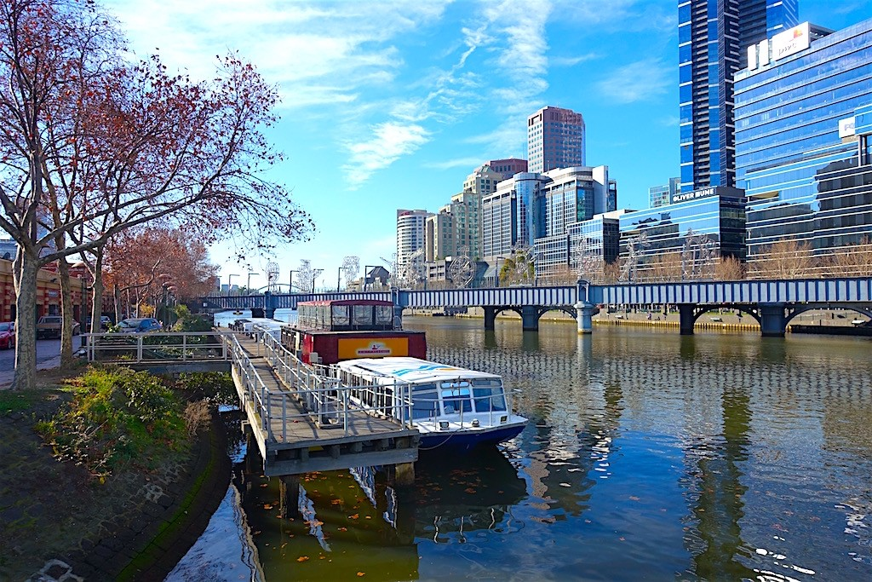

Foodies Bucket List Tour

HAIGH’S CHOCOLATE Block Arcade
Founded in 1915 by Alfred Haigh from Adelaide
Signature Frog

MOVIDA ORIGINAL Hosier Lane
Tapas Bar & Restaurant with a graffiti art exterior, Signature Anchoa & Croqueta

LUCY LIU Oliver Lane
Pan Asian street food flavours. An intriguing Asian influences from Shanghai, Hongkong, Seoul and Japan
Soft Shell Crab or Eggplant Pancake Roll

PASTUSO ACDC Lane
Peruvian bar and grill
Peruano ‘Snapper’ Ceviche, Pastel De Choclo
& Alpaca Croquette

CUMULUS INC Flinders Lane

Described as a ‘local’ eating-house and bar, rather than a restaurant – this favourite with large industrial New York style windows is located in an old rag trade building.

Lemon-curd Madeleine & coffee/tea

Some Of Our Favourite Spots On Tour…

Flinders St Station
Completed 1909 this station now enjoys 110,000 commuters and 1500 trains daily

Degrave’s Street
Originally a ‘service’ lane, now a vibrant and lively laneway

Block Arcade
Opened in 1892, visit this Italian designed shopping arcade for the Hopetoun Tea Rooms, Gewurzhaus Herb & Spice Merchants & Haigh’s Chocolates

Royal Arcade
Opened in 1870, this spectacular Victorian Arcade is the oldest in Australia.

Presgrave Place

With kitschy, framed artworks lining the brick walls, and an old-school laneway vibe. Killer brew at 30ml coffee & cocktails at Americano Bar

Hosier Lane
Blue stone laneway with some of our cities best street art embraced

Duckboard Place
Mary Fortune Bar

Malt House Lane
Eau De Vie Bar - Cocktails

+61401005582

