
Thompson Welding & Construction has over 15years experience working in the civil construction industry. We are currently working on the Thames Tideway project in London. We are subcontracted to Ferrovial Laing O’Rourke Joint Venture and provide a highly skilled workforce across many of the Thames Tideway sites.
We have a strong history in the piling industry both in the UK and in Australia. Notable projects include working on K7 and K10 Coal Berths with Lain O’rourke and Macksville Bridge over the Nambucca River for Smithbridge in NSW Australia.
About the Company Director:
Steven Thompson was born and raised in South East London. After finishing school he completed a Welding and Fabrication apprenticeship with B&M Welders and BAM Nuttall. During this time he gained a lot of experience in structural steel welding becoming a coded welder and working on both the O2 and Emirates stadiums.
Soon after completing his apprenticeship he moved over to Australia and was fortunate to work for some of the most prestigious civil construction companies: Laing O’Rourke, CB&I and Smithbridge. Here he was also able to gain additional qualifications in Rigging and Open Crane Operating making him an exceptional all-rounder on sites.
During the time in Australia time Steven worked on K7 and K10 Coal Berth constructions, the Tomago Gas Storage project and a bridge over the Nambucca river in Macksville, NSW. He also spent some time working Forgacs and Viking Marine gaining experience in ship building and well as Austunnel working on Sydneys North West rail Viaduct.
Since returning to England he has worked on FLO’s Northern Tube line extension in London and the Thames Tideway project, which is where Thompson Welding & Construction was founded.
The company has grown from strength to strength and provides teams of highly skilled trades dedicated tp project at hand







Projects:

– London’s new ‘super sewer’
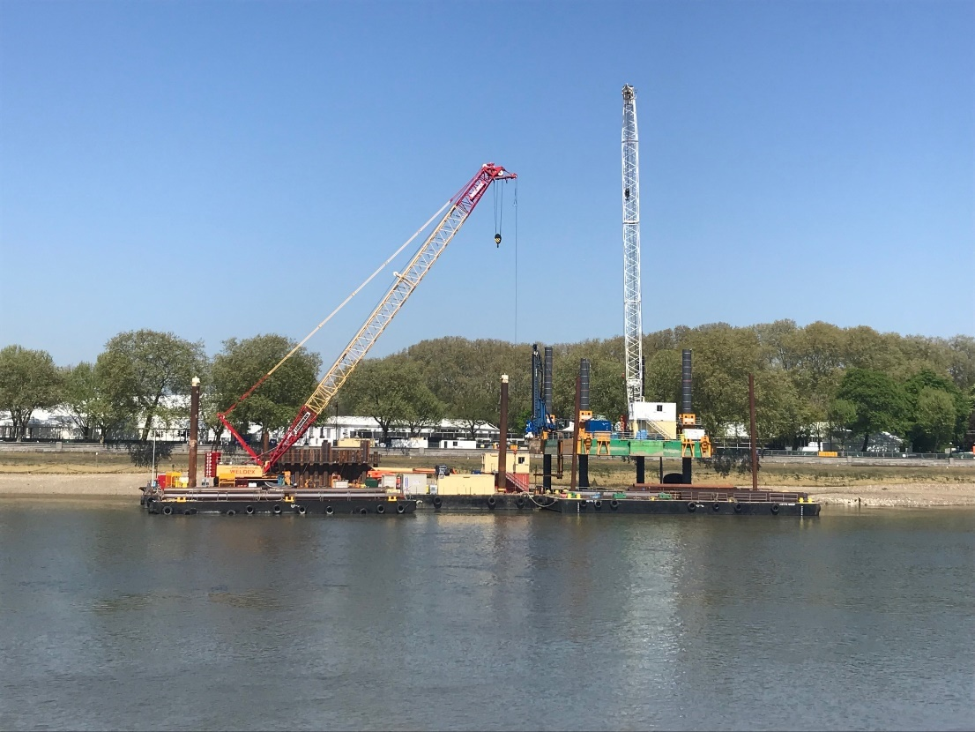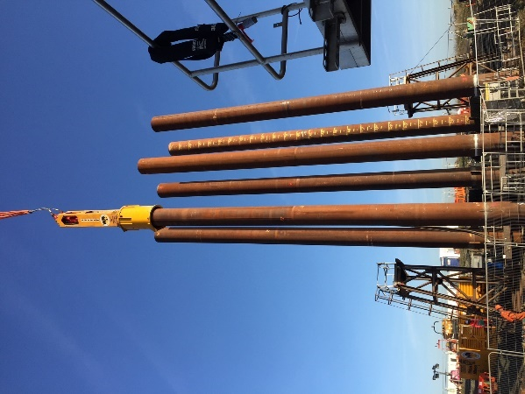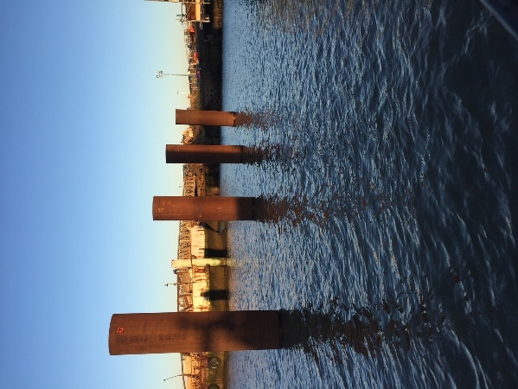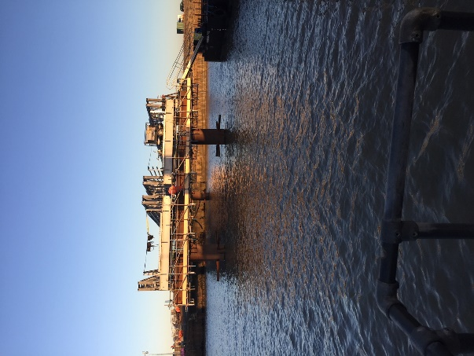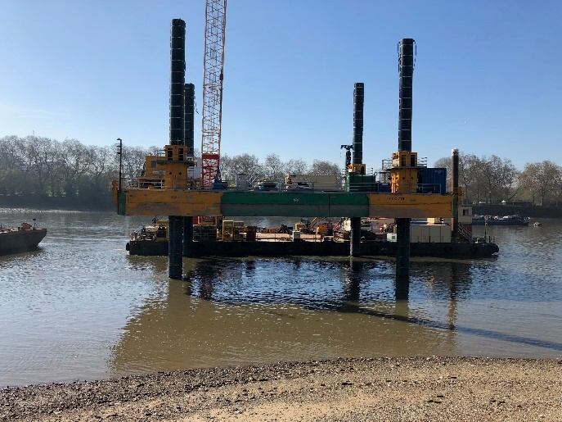

Northern Line Extension – London
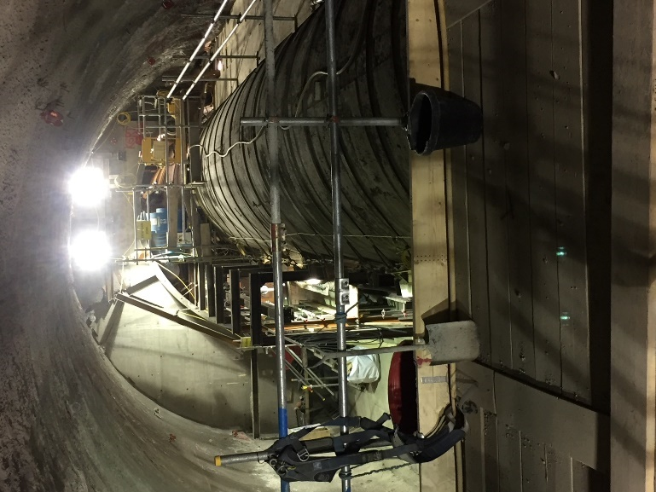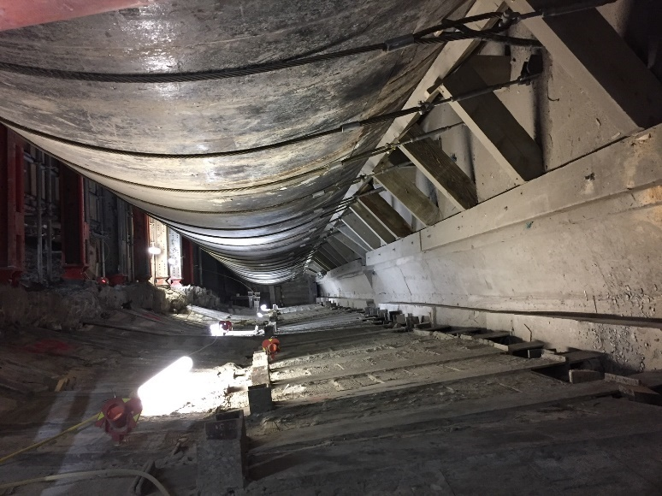

K7 & K10 Coal Berth – Newcastle Australia
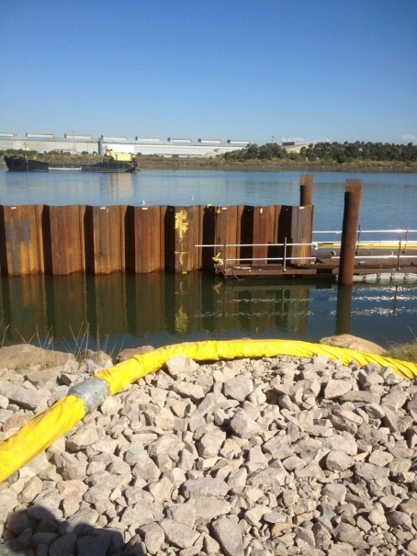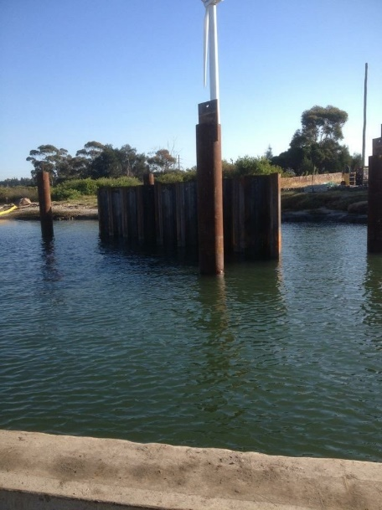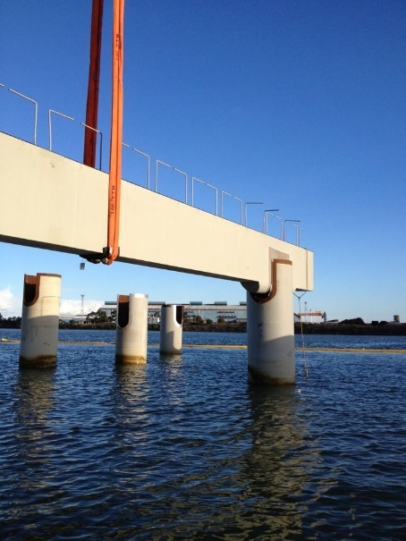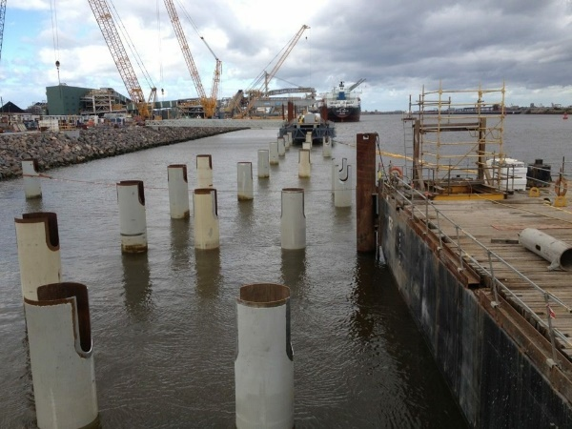

Tomago Gas Storage Works – Newcastle Australia
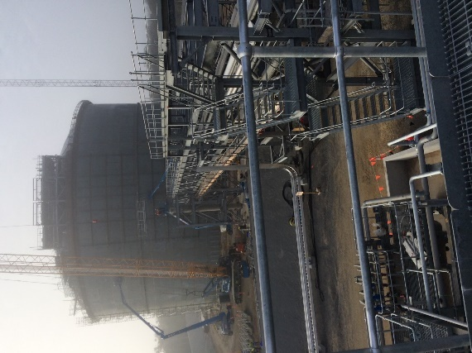
O2 Stadium – London
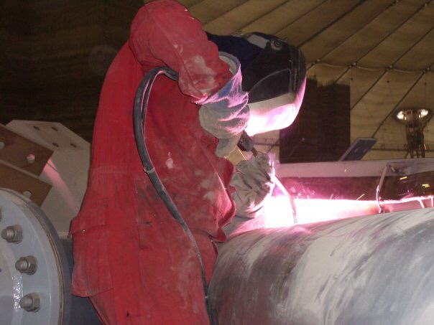
Other random pics
