  What is IBMPFD?
  Inclusion Body Myopathy associated with Paget's disease of bone and Frontotemporal Dementia is an autosomal dominant mutation in chromosome 9 of the VCP (Valosin Containing Protein) gene. Given the interaction with other genetic diseases, this mutation may also be known as VCP Disease or Disorder.
  Some patients have familial Amyotrophic Lateral Sclerosis (ALS or Lou Gehrig’s disease) or Parkinson’s which has been shown to have a pathogenic variant in VCP.
  Penetrance by Phenotype
  The frequency that IBMPFD or VCP Disease manifests itself in one, two, or three primary disorders.
  - IBM: Inclusion Body Myopathy
  - PDB: Paget’s Disease of the Bone
  - FTD: Frontotemporal Dementia
  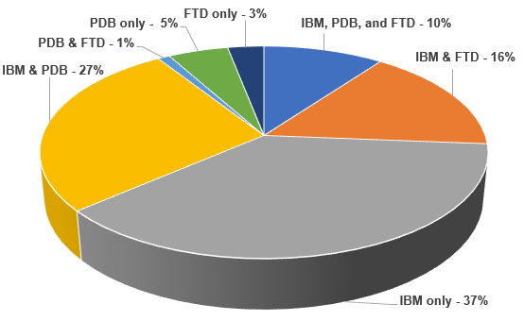
  Together We Can
  Make a Difference
  PATIENT SUPPORT
  Cure VCP Disease, Inc. is a 501(c)(3) which was formed to drive efforts to cure diseases related to mutations of the Valosin Containing Protein (VCP) gene. Our main goal is to bring patients and doctors together so we can help one another and drive research towards a cure. We are also trying to bring awareness to the medical community about our rare disease.
  We offer resources and support to patients, caregivers and doctors. Connect with us.
  - IBMPFD Facebook page
  - CureVCP.org
  - IBMPFD.com
  Cure VCP Disease, Inc.
  P.O. Box 6533
  Americus, GA 31709
  curevcpddisease@gmail.com
  www.curevcp.org
  
    - Do you have a family history of ADULT ONSET
  Muscle Weakness?
  Dementia?
  Bone Disease?
  ALS?
  Parkinson’s?
  IBM?
  You may consider talking to your doctor about a mutation of the VCP gene called
  IBMPFD
  Inclusion Body Myopathy associated with
  Paget's Disease of Bone and Frontotemporal Dementia.
    - 

 |  |  | Strength through numbers will help  US find a CURE!  RESEARCH:  The goal of the CoRDS registry is to connect as many patients and researchers as possible to help advance treatments and cures for rare diseases.  If you have been diagnosed with IBMPFD or VCP Disease, please help us by completing the patient registry through CoRDS.  Go to our website www.curevcp.org to access the CoRDS Registry.  The CoRDS registry is free for patients to enroll and for researchers to access.  Please elect for researchers to have access to your registry, as that will greatly assist in the drive for a cure, especially when drug trials are recruiting patients.   |  |  | TREATMENTS:  There is an approved treatment for Paget's disease of bone, so early testing for this disorder is very important.  There are no known cures or treatments for the Inclusion Body Myopathy or Frontotemporal Dementia. Consult with your doctor about physical therapy, stretching, diet and mobility aids.
  SYMPTOMS:
  IMBPFD, a VCP Disease, is an adult onset disorder that can affect the muscles, bones, and brain, and an affected patient may have any combination of the following conditions:
  
  Inclusion Body Myopathy: The first symptom of IBMPFD is often muscle weakness (myopathy). Typically, patients first notice difficulty raising arms, losing balance or difficulty climbing stairs. As the disorder progresses, weakness develops in the other muscles in the arms, legs and core muscles. Muscle weakness can also affect respiratory and heart (cardiac) muscles. This disorder may first present in an individual’s late 30’s and over time occurs in approximately 90% of individuals with VCP Disease.
  
  
  Paget’s disease of bone: Bone pain, particularly in the hips and spine, is usually the major symptom of Paget’s disease. It most often affects bones of the hips, spine, and skull, and the long bones of the arms and legs. Paget’s disease affects half of individuals with VCP Disease and typically first presents in a person’s 30’s or 40’s, which is a much earlier age than those without VCP Disease.
  Frontotemporal Dementia: In about one-third of people with VCP Disease, the disorder also affects the brain. FTD typically changes personality, behavior, language and speech. FTD typically presents in the mid-50’s.
  
  Amyotrophic Lateral Sclerosis (ALS or Lou Gehrig’s disease): ALS occurs in approximately 10% of individuals with VCP Disease. Symptoms include increased muscle tone, weakness, muscle wasting, muscle cramps, difficulty swallowing and speaking.
  DIAGNOSIS:
  The only way of diagnosing VCP Disease is through genetic testing. Consult with your doctor about testing for mutations of the VCP gene.
  For information about genetic testing, our two medical advisors are available as resources:
  - Dr. Virginia Kimonis, Medical Geneticist at University of California, Irvine, vkimonis@uci.edu
  - Dr. Conrad Weihl, Neuromuscular Specialist at Washington University, weihlc@wustl.edu
  