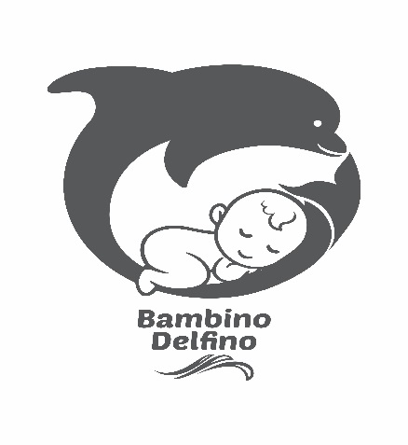

Brief Discretion
Hi there,
I'm trying to get an outstanding and unique design for my new product. I’m in baby products business. We are launching an organic,100% burp cloth for our online store. The packaging design is very important to our business. We are looking for something simple and unique. Our brand name is Bambino Delfina which means Baby Dolphin in Italian. We also have dolphin prints on the burp cloth. Our burp cloth made of organic, hypoallergenic, breathable and ultra soft 100% cotton. Each box has 5 burp cloth. Its made with love and care for delicate and sensitive baby skin. I will attach samples of the burp cloth colors for you to get an idea about the product. Design.
Size:
25*22*3.5cm.

This GOTS image has to be included in the package too.

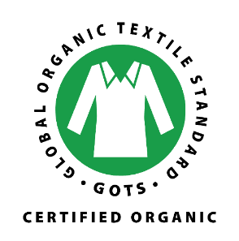

I will attach two files for our logo and our barcode , please remove this (Baby Burp Cloth new) from the barcode thank you

