LARRY COLDENSPORE- will try anything to make a buck. Larry, a Winnebago salesman, has a different pastel polyester suit for every day of the month. He was a football star at Umatilla High carrying the ball 98 yards before realizing he was running the wrong way. He then carried the ball back for another 98 yards before finally scoring. This 196 yard run still stands today as the world record for distance in an American High School Football game.

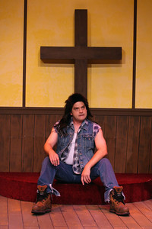
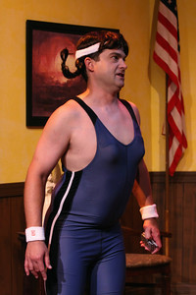
SHAYNA BEEHIMER- granddaughter to Minerva. SHAYNA is a three-time Umatilla High School champion in the Octathalon. She holds two silver medals and one bronze medal. The Octathalon incorporates eight elements: cross country skiing, shooting, tree-climbing, bass-fishing, guitar playing, taxidermy, basic first aid and appliance repair. She loves physical fitness, but she once assaulted a Pilates instructor because ‘Pilates’ is insult to serious athletes.

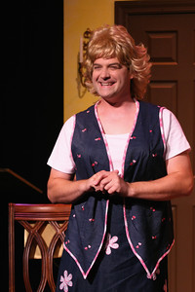
SHERRY COLDENSPORE- is the entertainment coordinator for the Auxiliary league. Sherry’s loves are drama, music and saltwater taffy. She is sweet, kind and soft-spoken. Unfortunately, she is married to the meanest man in Umatilla.

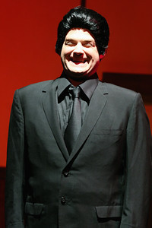
RUPERT EIKENBERRY- is a mortician and the owner of the ‘ASH IN A FLASH’ crematorium. He is always well-dressed and proper, because, as he puts it, you never know when “your next job is going to get hit by a bus.” Rupert’s hobby is studying the preservation qualities of excess embalming fluid on organic things. He has on display a 27 year-old, 22 pound Royal Jubilee Watermelon, as well as his 118 year-old great-great uncle ‘T-Bone’ Eikenberry. It should be noted that both look as fresh as they day they were ‘picked.’

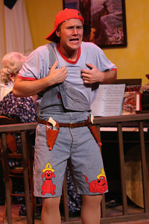
HORSESHOE DUMPLING- was raised by a herd of cows. He and his brother, Clem, were found at the age of three roaming wild in a dairy farm. It is suspected that they were left on the doorstep of the farmer, but then overlooked for next 36 months. A Guernsey cow named, Tallulah Bell, is listed as the legal guardian of the boys.
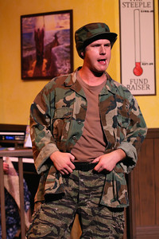
STUDLEY GRIGGS- loves to hunt more than Nature or Natural Selection ever meant for any one man to love hunting. He was recently involved in a voluntary military survival study where, he was left half-naked in a wooded area with no food or water. He emerged 2 weeks later 2 lbs. heavier wearing a three-piece suit made from elk, bear, and weasel skins.
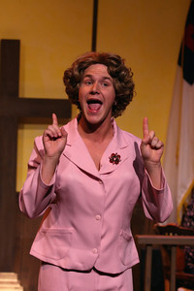
CLORETTA POWERS- is an inspirational speaker. Cloretta is determined to make the world a better place to live. She is known throughout Umatilla as ‘the one who left.’ After attending the Umatilla Community College, Cloretta traveled to Orlando, Florida where she worked at Disney World selling frozen bananas at the entrance to the Jungle Cruise. This made her the fourth person to ever leave the Umatilla city limits without being arrested or drafted.
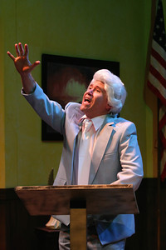
REV. HARV FELDSPAR- is the Reverend of the Umatilla Second Christian Church. Rev. Feldspar is an outsider to Umatilla. He moved here 20 years ago from Bent Back Falls, Kentucky. Harv’s contributions to the Umatilla Second Christian Church include co-ed softball games, imported root beer, and a heated toilet seat in the church’s basement restroom.
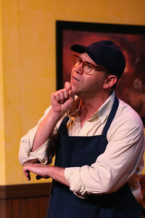
HARLEY BUFORD- Buford’s Meat and Seafood Store has been closed by the Board of Health six times for violations including substitution of opossum meat for veal, unsanitary conditions, and unidentifiable particles in the ground chuck.
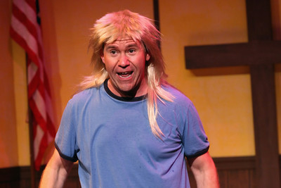
SAMMY COLDENSPORE is a free spirit. Most of the time, he is not allowed outside because he often gets the scent of other animals in his nostrils and runs away. He has been promised a new pet skunk if he will wear his clothes when in public.
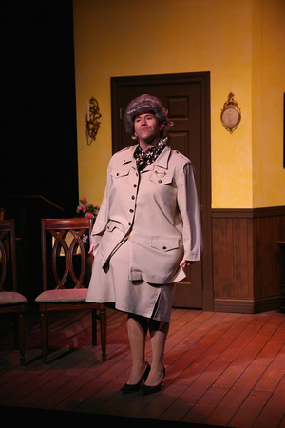
MINERVA BEEHIMER- is the wealthiest woman in town, and she uses her wealth to intimidate and bully. Minerva still chases younger boys, chops wood, and for pleasure, she loves to participate in championship wrestling. She is currently with a much younger man, Myron Posey
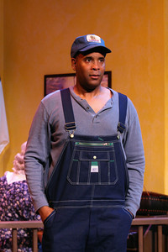
JEFFERSON GLORY- Revita’s son. Jefferson is said to have the "magic touch" when it comes to farming. Three-time winner of the Giant Yellow Squash contest, he recently was chosen by FIELD HAND Magazine as "Best Plower." His only regret was his recent mishap at Piggo's Bar and Grill when a stranger to the town insulted Jefferson's 4 feet, 6-inch cucumber. Piggo's is now closed for repairs.
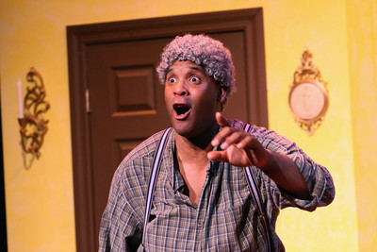
DARNELL NUSSPICKLE- is the caretaker of the Umatilla Second Christian Church. His responsibilities range from custodial jobs to digging the graves in the church cemetery. There are rumors that he’s a heavy drinker after he was found sleeping in an open grave on top of the recently deceased Cora Flayley.
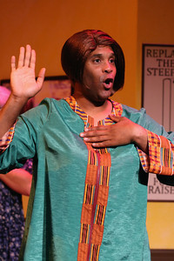
REVITA GLORY- is an African American choir director and choreographer. She was asked to join the Umatilla Auxiliary League after a phone interview, and needless to say, the ladies were shocked when she arrived. Revita was very involved in her church in South Carolina-- The Watchacootchie Church of Holy Momentum.

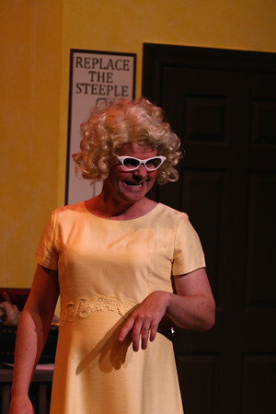
DAISY FELDSPAR- has been married to Harv for the past 20 years. She is the President of the Umatilla Christian Auxiliary League of Women. Her hobbies include indoor-herb gardening and replacing zippers in outwear.

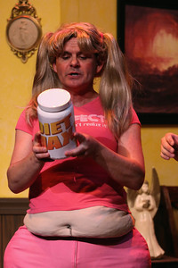
FELICITY SHIRKWATER- is a smart, young girl. Her goal is to leave Pulander County. At the State Fair, she shocked the community with a reading from her essay-- "I HATE IT HERE.” Felicity lives in the shadow of her mother who was a former beauty queen.
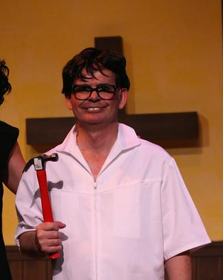
DALE SHIRKWATER- is a dentist. His first love is teeth, but his second is fishing. Dale is listed in Fisherman’s Paradise Magazine as having the most “fish related” injuries of any living angler, and because of these injuries he is unable to recognize up from down and left from right. He has been suspended from practicing Dentistry, until this condition can be corrected.

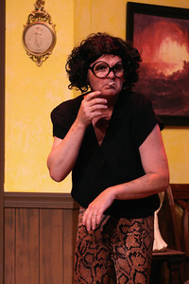
IRMA SNEAD- a local seamstress, has relocated to the area after being banned from Midwest for an incident involving a boy's choir, 70 yards of Taffeta, and a biker named "SHARK TOOTH." She loves to wear leopard prints, and prides herself on her 'eye for fashion.'

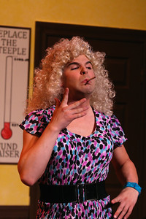
NAOMI MAY HOOKER- a graduate of the Pikewater Beauty and Charm School. Naomi May is a hardworking career-oriented woman. Her savings, along with an endowment from the late Buddy Grabs of Buddy Grabs Trout Boats, has enabled her to branch out into real estate. She has recently been featured in the Plastic Surgeon's Magazine- TIGHT as "the Most Surgically Altered Woman of the Year".
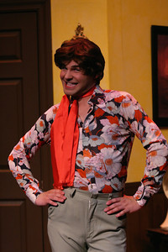
MYRON POSEY- is the most flamboyant man in Umatilla. Myron loves to make decorative door hangings and driftwood coffee tables. He is somewhat outrageous, and once drove 650 miles to hear Barbra Streisand sing. Some say that the only reason he is allowed to stay in Umatilla is because of his relationship with Minerva Beehimer, but others feel it’s because of his crab puffs, which are regionally renown.

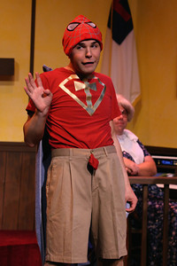
FRANKIE FELDSPAR- rarely leaves the basement of their home. Due to his serious orthodontic needs as well as his ‘coke bottle glasses’, he is unable to survive in the real world. He is a sweet kid who lives through his religion based comic book collection. His favorite comic book heroes are SuperMoses, Captain Absolution, and the Cross-Men Action Team.

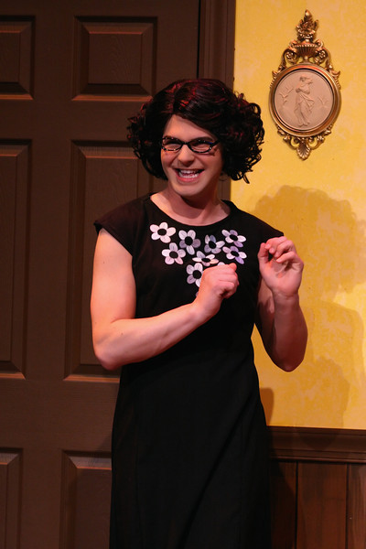
MAISY SHIRKWATER- is the twin sister of Daisy Feldspar. Maisy was born one year later, because of a difficult delivery, and their birth is still listed in Ripley's Believe It Or Not. Some describe Maisy as a rosebush with a beautiful flowering exterior but many thorns lying just beneath the surface.
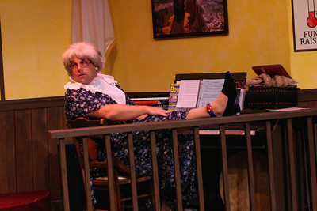
DARLENE OPAL - is the keyboardist for the Church. She has been released from the County Jail on ‘Church Arrest” to play for the services and musical events. Darlene has a problem with shoplifting. She once tried to walk out of a PEP BOYS with two steel-belted radial tires. Currently, her electronic ankle bracelet keeps track of her activities,

