CHURCH GIRLS Umatilla, USA
A new campy, cheeky, audacious musical comedy. The ladies of the Umatilla Second Christian Church Women’s Auxiliary League are getting together to produce their annual Mother’s Day Pageant. Six actors play every character in this singing, acting, dancing, improv tour de force. As the ‘Church Girls’ prepare for their pageant, chaos and calamity bring out less than ‘saintly’ behavior. The result is Heaven sent hilarity!
“It’s hoot. Actually, that is too mild a word. At its heart, this is a showcase for six journeymen actors (and one musician) to strut their prodigious talents...The result is like the funnyman’s version of an ESPN highlight reel – nonstop humor from first-rate pros. When they turn their attention to the serious business of humor – to primping and eyelash-batting, to hip-wiggling, to catty banter, to the deliciously clever maze of men playing women who are mocking men – it’s a ball.”—Review by David Lyman, Cincinnati Enquirer, 2010--
Commonwealth Theatre’s “Church Girls” Gets 4 Star LCT Review
Panelists for the League of Cincinnati Theatres (LCT) have recognized the Commonwealth Theatre’s Church Girls with a 4 star review.
The ladies of the Umatilla Second Christian Church Women’s Auxiliary League are
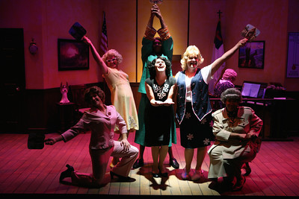
getting together to produce their annual Mother’s Day Pageant, and after the chaos and calamity it brings out less than ‘saintly’ behavior. The result is Heaven sent hilarity!
Panelists wrote, “brimming with sassy, brassy, campy, and just plain eccentric women all played by men. They play multiple women and men with breathtakingly quick changes and spot on character changes. The girls will win you over during the hour and 50 minutes you'll spend with them.” “Big broad fun... A lot of very witty gags and engaging characters, full of belly laughs.”
