SuperCoaches

What our brand stands for. Who we are. What makes us different. Our Values. What we want to be known for:
- Science based and results driven
- We strive for excellence in our product delivery and customer service
- We make the complex appear easy
- Students learn by doing
- We care about human movement and doing it right
- We care about an industry that we have been in for over 20 years
- We make trainers great
- We continuously improve our product
- We have the highest CEC’s per course hour and dollar
- We do the right thing
- We want to improve the standard of Personal trainers nationally/globally

If our business was a person it would…:
- Be strong and healthy
- It would drive a BMW because its tried/tested/strong/dynamic/efficient
- It would train every day, eat well, sleep well
- It would hang out with likeminded, high energy people who want to be better than average
- It would be continuously improving by personal development

Our competition do the following well:
- Marketing and promotion
- Have multiple accredited certification courses (eg Functional Training Institute has 16)
- Have a Social media presence and large following

Our competition could be better at:
- Website flow and ease of use
- Professional video and imagery on all platforms

How we are different:
- We have available the most CEC’s per dollar (22 for $899)
- Passionate CEO and founder
- Learn by doing

Other Brands we like
- Nike
- Apple
- BMW

More about us:
We are an education company that provides Fitness Australia accredited Strength training courses for Personal Trainers Professional Development. Our courses are delivered as Face 2 Face workshops and online education.
We would describe ourselves in 5 words or less as “We create Super Coaches”
We want people to think our courses are a Game Changer for their training and business
We look up to:
- Strong by Science (Greg Knukols)
- Eric Cressey Performance
- FRC Dr Spina
Our experience sets us apart from other providers because our team of Educators includes a coach (Brendon Harris) with over 20 years hands on in Personal Training, Strength and Conditioning, Professional Sports team coaching and Presenter. The team also includes a leading Sydney Osteopath (Paulo Driscoll) with a passion for human movement.
Our courses are in-depth and designed for the Personal Trainer looking to elevate their skill and develop their reputation as a trainer that gets results.
Our brand came about because: Leaner Stronger was established in 2015 by Brendon Harris. Brendon Harris has been in the fitness industry for over 20 years and saw a gap in skill between a trainer completing Cert 4 Qualification and what was needed on the gym floor to safely train a person in lifting. It can take a trainer years to have assessed a variety of movement patterns and continue their education and improvement on the gym floor. Brendon saw a way to fast track a trainers expertise by coaching them in what he had taken 20 years to learn. He saw the fitness industry moving back to lifting however the education of trainers was not keeping up with the shift. The big lifts are back in fashion, gyms everywhere are renovating to have lifting racks yet trainers have not been adequately upskilled to assess and load safely and correctly for the lift.
Brendon Harris Mini Bio: 23 years in the Fitness Industry as a trainer, education provider, manager and gym owner. Qualifications include a Bachelor of Physical Education, Certified Strength and Conditioning Specialist, State Licensed Weight Lifting Coach, Cert 4 in Training and Assessment
Initially we had three (3) four hour courses accredited with Fitness Australia, they were named as follows:

Big On Basics: the Squat (9 CEC’s)
Big On Basics: the Deadlift (13 CEC’s)
Big On Basics: the Press (13 CEC’S)
In response to learnings from the early workshops and student feedback the courses evolved in to 2 Levels as there was too much to cover in one day. Each lift now had 2 levels to complete therefore making the new course format a 6 day course – dispensed as one day per month for 6 months.
This 6 day version was launched in 2016.
In 2018 we evolved the course again in response to student feedback. The courses are now presented as a Superweekend, two days of intense learning. The feedback is positive as students and coaches alike are able to truly turn up their energy levels for one ‘all out ‘weekend of learning and lifting.
By the end of 2018 there will be a fully functional membership site as a resource for students and courses available to do online.

Why we do what we do!
Here is a student’s feedback after completing one Superweekend.
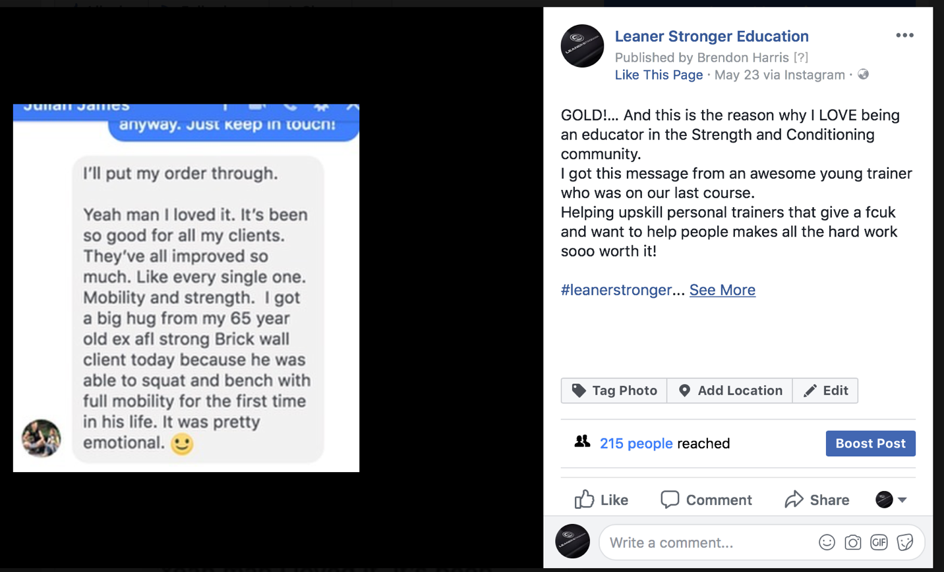

Target market:

Our target audience are qualifies Personal Trainers.
Size: There are currently 28,000 total members enrolled with one of the governing bodies, Fitness Australia
19,422 of which are registered Personal Trainers with 5,731 listing Strength and Conditioning as their special skill.
58% are female (11,265)
48% are male (9,323)
34% of registered Personal Trainers are in NSW (6,603) where our business is currently located

Customer profile:
Our niche demographic is:
- Between 27 and 32 y/o
- Male and Female (48% male, 52% female)
- Has approx. 15-25 clients per week
- Earnings of approx. $60-70k
- Turnover $80-100k
- No children
They have reached a plateau financially and their business has become static. They no longer stand out from other trainers and lately some clients have not been achieving results. They have experienced a client situation they were unable to fix and program for. These factors have made them think they need to change and improve but don’t know how. It has also triggered a fear of failure, if they keep going this way they will lose clients. They have no time to stop and solve this problem as they go home after a long day and dive in to programming and watching you tube to problem solve.
They got to this position as a result of being successful initially and gaining more clients, however they are coming across more problematic clients and found they don’t have the skillset, systems or time to effectively deal with them.

Other Logos we like:
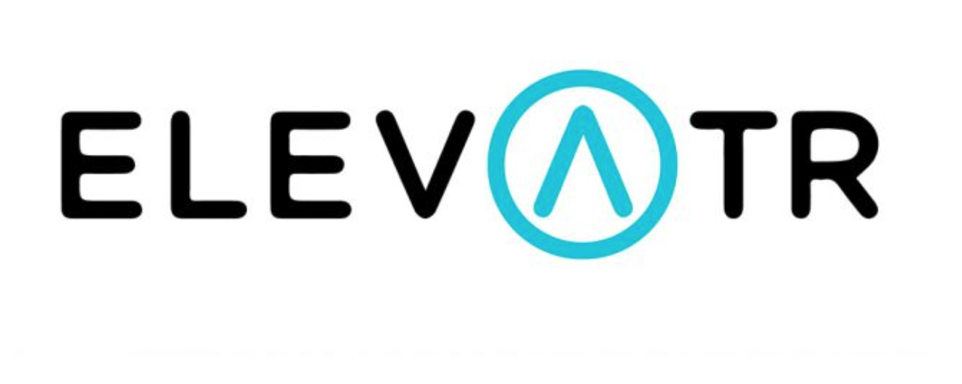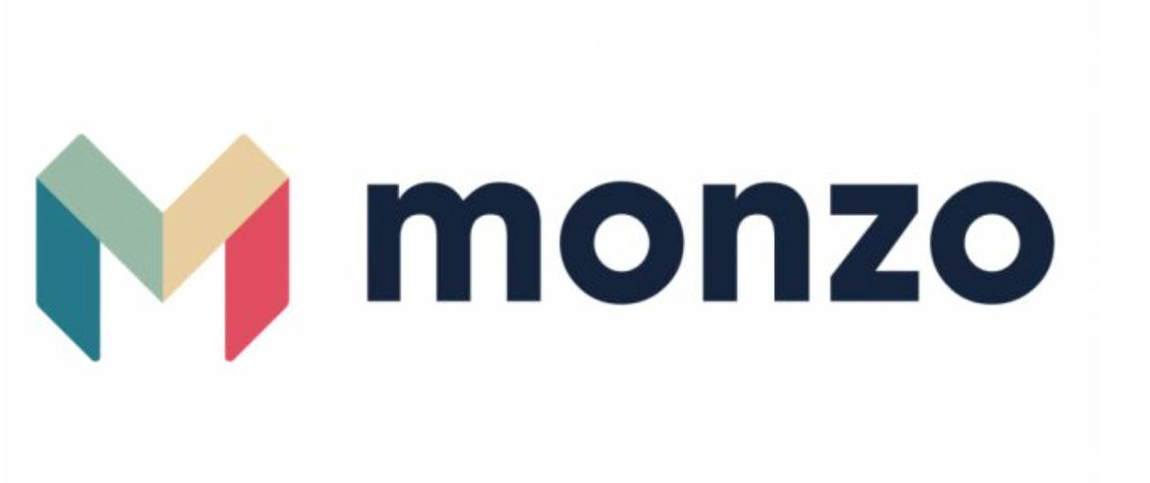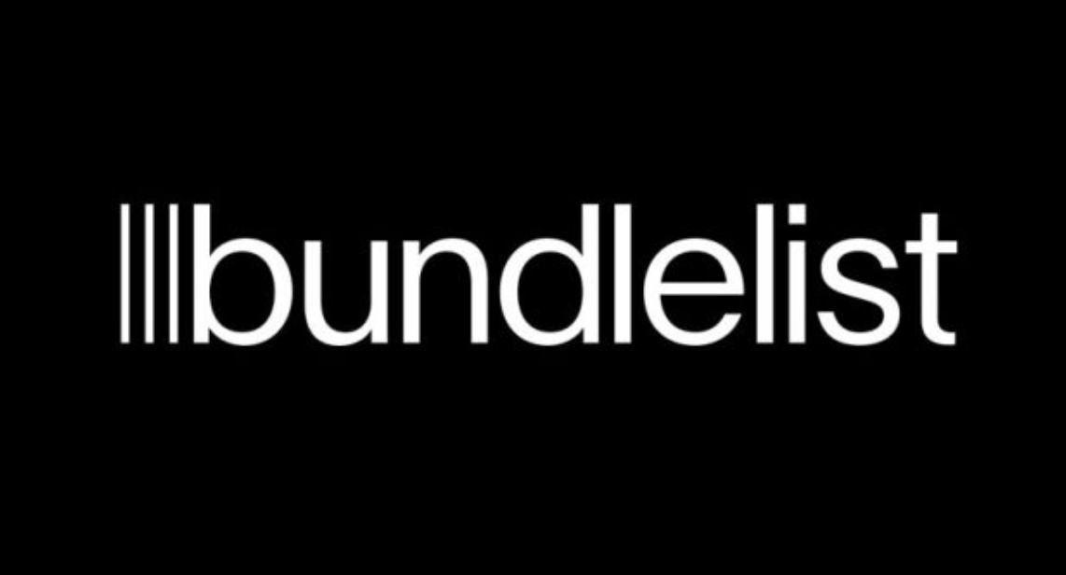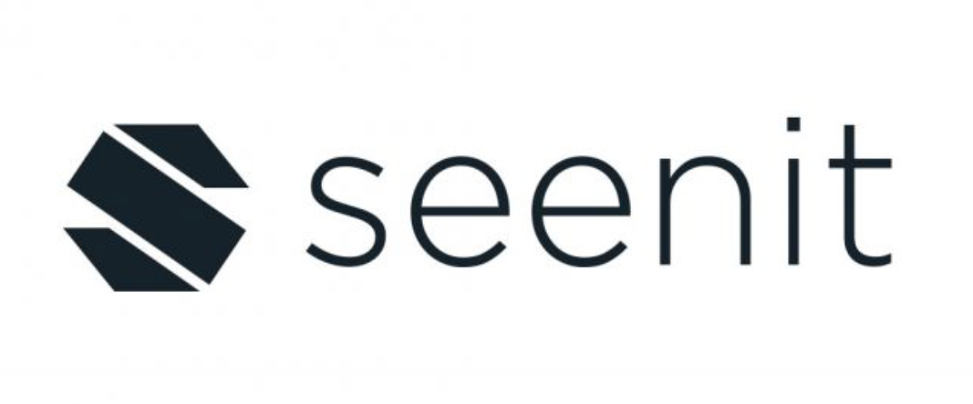

What we want our brand to look like:
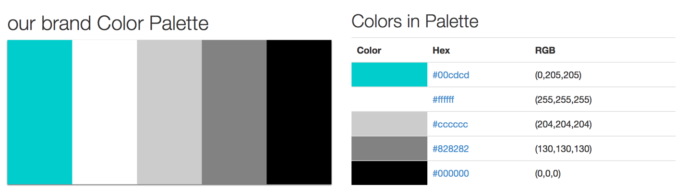

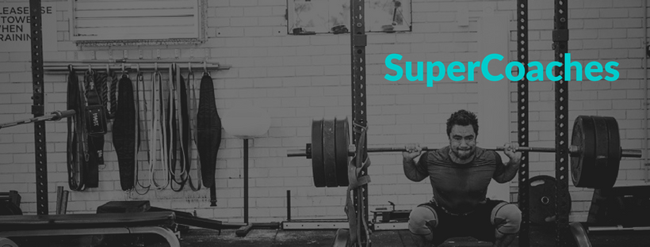
The logo needs to be scalable, to be clean and clear even on something as small as a pen or instagram profile pic and remain as clean and clear if it were to be on a T-Shirt or a Billboard.
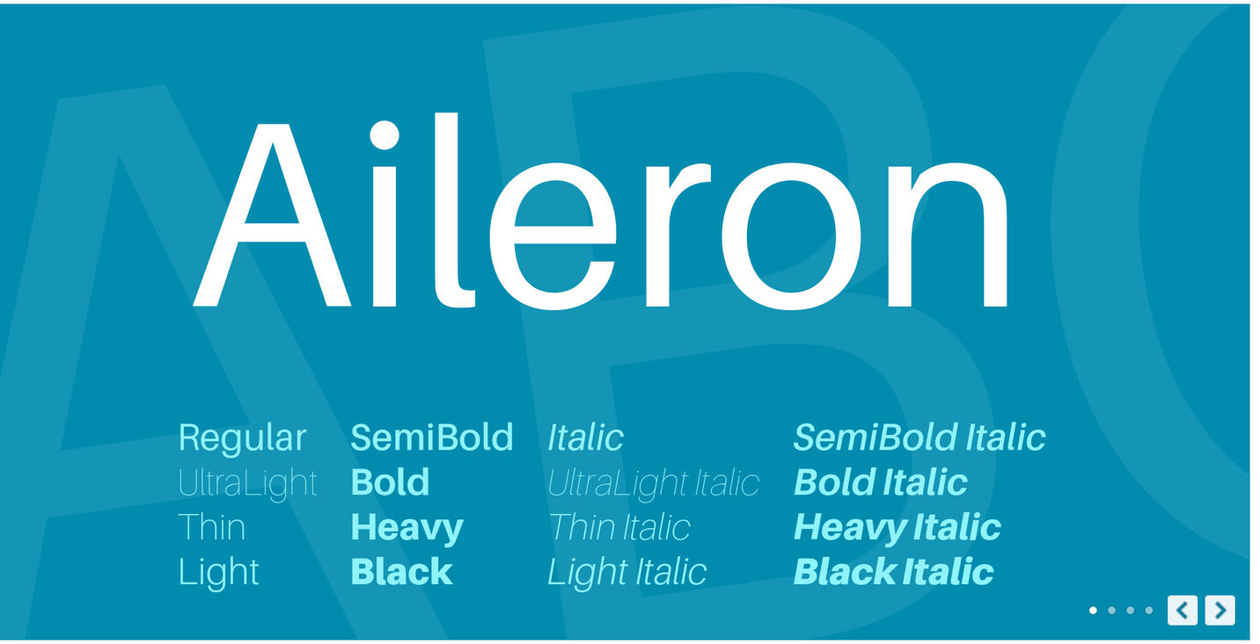
We want simple font and simple design with no reference to literal/cartoon/outline images of weights/gyms/bodies within the logo. We would like the flexibility of it to work as a silhouette (on black background as well as white background)
We want an EPS file
We want the logo as a transparent file too (with no white background)
To stay simple, we want the logo to be flat, not dimensional
Colours to be used in the design as shown in the HEX code palette.

Our Pinterest Board
