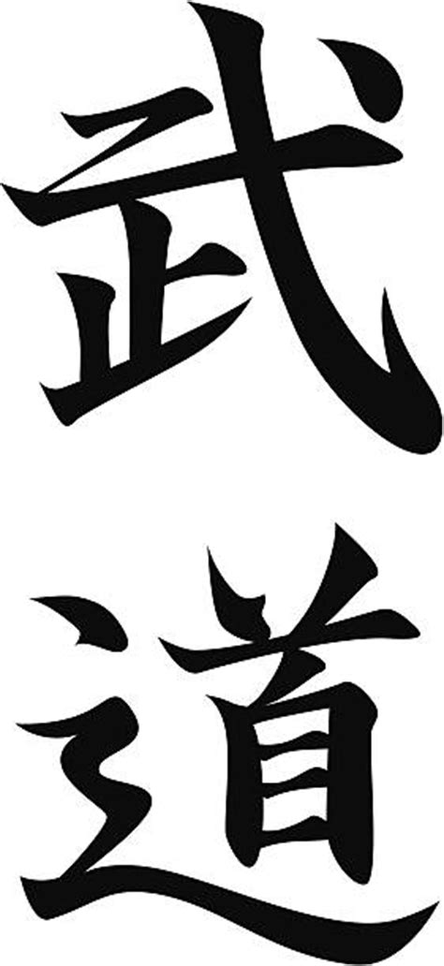

This means Martial Art. It was printed in light yellow inside of a big black badge watermark in the background of the whole certificate.

