MAID SYSTEM OPERATION


The operator moves a small image of the vessel from the center of the interactive monitor with their fingertip to the targeted location where they want to position their vessel. With a touch of the monitor, the MAID System is engaged, and the vessel’s movement, velocity and direction are autonomously controlled as the system guides the vessel to the predetermined targeted location, autonomously stopping the vessel at a default distance from the dock, regardless of normal wind and water currents.
The MAID System’s photographic infrared night vision systems map the surrounding environment, day, or night, for several hundred feet around the vessel and autonomously validate the targeted location is of sufficient area to accommodate the dimensions of the vessel. Once the targeted location area is confirmed as sufficient, the system continually maps surrounding environment and CPU calculates collision free path of trajectory required and autonomously controls the drive systems to maneuver the vessel to the desired final position, in the preselected orientation.
Innovative robotic learn-in technologies are incorporated within the MAID System collecting vessel performance and experiences as MAID operates, building its own knowledge base so as to become more precise with every operation. This innovative technology enables MAID to seamlessly integrate with any sized vessel, diverse propulsion, mechanical and electronic systems. The MAID System is designed to operate with precision at any dock, in any marina, anywhere in the world.

Operation summary:
  - When vessel is turned on, system is active and immediately has awareness of surrounding environment and objects, day or night.
  - Operator preselects orientation of vessel in desired final position relative to another object on interactive touch screen monitor by dragging vessel image to desired final position relative to another object/s.
  - System recognises command and validates the targeted location area is sufficient to accommodate the dimensions of the vessel or it will not engage.
  - Once targeted location area is confirmed as sufficient, the system continually maps surrounding environment in real time and CPU calculates collision free path of trajectory required to deliver vessel to desired final position, in the preselected orientation, relative to another object.
  - Drive systems are engaged automatically by CPU and manoeuvre vessel on calculated path of trajectory, to preselected final position.
  - MAID System autonomously maintains final position.

Docking and positioning sequences

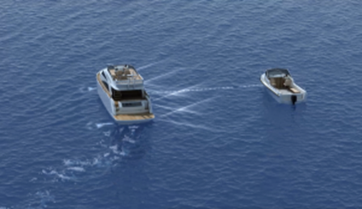

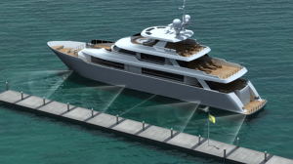

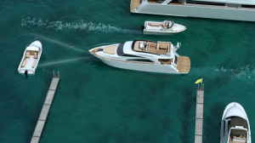

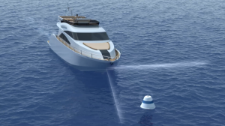

SIDE DOCKING MODE
Pre-select desired location in relation to dock on interactive monitor and the vessel will move towards the dock or object and autonomously stop 2 feet from dock or object, remaining at that location regardless of normal wind and currents until otherwise directed.

DOCK DEPARTURE MODE
When a departure location is selected on the interactive monitor, MAID will calculate a safe path of travel and autonomously depart sideways from a dock or object at a controlled velocity and maintain final selected distance from dock regardless of normal wind or water currents. A pre-selected distance up to 60 feet from dock can be pre-selected.

BUOY SEEKING MODE
When buoy location is selected on the interactive monitor up to 200 feet ahead of vessel, the system will autonomously control drive and direction, stopping vessel 3 feet from buoy until vessel is secured, regardless of normal wind and water currents.

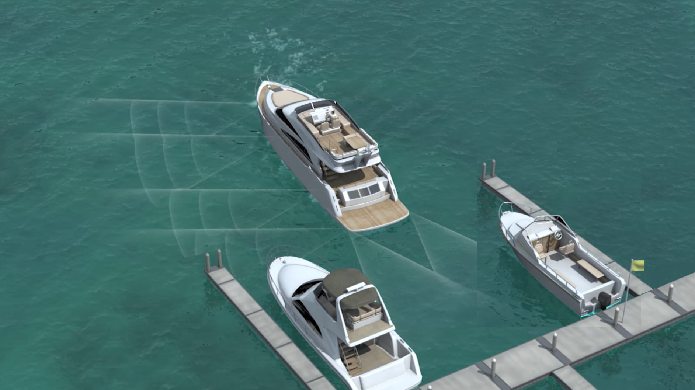

ACCIDENT AVOIDANCE MODE
When operating a marine vessel in congested areas, accident avoidance mode autonomously controls vessel velocity at 5 knots, autonomously stopping vessel 20 feet from an object in the vessel’s path of travel, and remaining at this position until object moves away or manually directed otherwise.

VESSEL TO VESSEL POSITIONING MODE
A pre-selected location from another vessel or object can be selected on the interactive monitor. Thereafter, MAID will calculate a safe path of travel and autonomously move the vessel sideways at a controlled velocity to the pre-selected location relative to a static or moving vessel, and autonomously maintains pre-selected position.

SLIP DOCKING/POSITIONING
When the operator selects a location on the interactive monitor between two objects, the vessel will autonomously maintain a 2 feet clearance between the side of their vessel and side dock or object. MAID stops the rear of the vessel three feet from the dock and maintains position autonomously regardless of normal wind or water currents.

REVERSE DOCKING

When selecting reverse location on interactive monitor with stern of the vessel facing a dock, vessel will reverse in a direct path of travel, autonomously stopping with stern of vessel 3 feet from dock, maintaining position at 90 degrees to dock, regardless of normal wind or water currents.

